

**School of Computer Science and Engineering**

VIT Chennai

Vandalur - Kelambakkam Road, Chennai - 600127

**FINAL REPORT**

**PROJECT TITLE: COSTUME KINGDOM.COM**

**PROGRAMME:** B. TECH.

**COURSE:** INTERNET AND WEB PROGRAMMING

**SLOT:** A2

**FACULTY:** Dr.K.P. VIJAYAKUMAR

**COMPONENT:** EMBEDDED PROJECT (J COMPONENT)

**TEAM MEMBERS**

SHERAL SIMON WASKAR – 20BCE1182

KATASANI DURGA PRAVALIKA ­­- 20BCE1427

KOVI YASASWINI – 20BCE1470

**ACKNOWLEDGEMENT**

On the very outset of this report, we would like to extend our sincere & heartfelt obligation towards all the personages who have helped us in this endeavor. Without their active guidance, help, cooperation & encouragement, we would not have made headway in the project.

We are ineffably indebted to Dr. K.P. Vijayakumar Sir for conscientious guidance and encouragement to accomplish this project.

We are extremely thankful and pay our gratitude to our faculty Dr. K.P. Vijayakumar Sir for his valuable guidance and support on completion of this project successfully. We are ineffably indebted to our Sir for conscientious guidance and encouragement to accomplish this project.

We extend our gratitude to VIT Chennai for giving us this opportunity.

We also acknowledge with a deep sense of reverence, our gratitude towards our parents and member of our families, who have always supported us morally as well as economically.

At last but not least gratitude goes to all of our friends who directly or indirectly

helped us to complete this project report.

Any omission in this brief acknowledgement does not mean lack of gratitude.

Thanking You,

Sheral Simon Waskar – 20BCE1182

Katasani Durga Pravalika ­­– 20BCE1427

Kovi Yasaswini – 20BCE1470

**ABSTRACT:**

The growing popularity of online clothing rentals is fueled by the desire to keep up with the latest trends. Due to convenient access and affordable amazing selections, customers now prefer to buy rental clothes online. The online clothing rental market is expected to grow due to lifestyle changes and popularity of party dresses, designer dresses, and dinner suits. It is more cost-effective to rent our favorite clothing for the day than to purchase the clothes we wear just seldom to events and parties.

According to research every year, more than 3,50,000 tons of old clothes are discarded at landfills in the UK and about 30% of clothing is not worn at least once a year. Excessive use and indiscriminate disposal of unwanted clothing has become a global problem. Therefore, product rental will be considered the most sustainable way to use clothing today, as industries use sustainability as their key business plan to attract more customers. As the rental costume market is expanding right now, we choose to create a website called "COSTUME KINGDOM.COM" for our project.

**TABLE OF CONTENT**

|  |  |  |
| --- | --- | --- |
| Sr. No. | Title | Pg. No. |
| 1. | Acknowledgement | 2 |
| 2. | Abstract | 3 |
| 3. | Introduction | 5 |
| 4. | Literature Survey | 6 |
| 5. | System Models(ER Diagram) | 8 |
| 6. | DFD | 9 |
| 7. | System and Software Specification | 12 |
| 8. | Proposed System | 12 |
| 9. | System Architecture | 12 |
| 10. | Modules Description | 13 |
| 11. | Results | 70 |
| 12. | Conclusion | 82 |
| 13. | Future Work | 83 |
| 14. | References | 83 |

**INTRODUCTION:**

As the cost of living has been increased in the recent days, it is very difficult for the middleclass persons to afford the costly costumes that they wish to wear on their memorable days. So, after a lot of discussion with our teammates we came up with an idea of rental costumes which will be very helpful for various sections of people who feel difficult in buying costumes that are very expensive but are needy. Customers need not buy those expensive dresses but only pay rent and can wear the best dresses for which they were always dreaming and make their important day happy and also memorable. The upper-class people who had purchased the costly clothes for an occasion and they don’t require it anymore can also sell their clothes at reasonable prices. Not only for the upper class, if anyone else who wants to sell their clothes to us, they are most welcome.

We are also planning to give our target customers as much benefits as we can, we can provide the dresses at the doorsteps to our customers and also, we will pick up the dress from their doorsteps, they don't need to worry about that. They only need to do is that they has to book their dress according to their fitting in advance. This website will be helpful to wide range of people to make their special moments even more special, and we try to provide all the varieties of costumes to the customers. The website is user friendly, and the customer can even see the dress virtually with the help of video call with our team will explain about the costume in detail.

**LITERATURE SURVEY**

**Online Renting in the Fashion Contex**

In a number of contexts, including automobile sharing, bike sharing, and lodging sharing, collaborative consumption has been thoroughly explored. The literature that is now available examines collaborative fashion consumption from three main angles: the environment, the company, and the consumer. In essence, a significant problem that has attracted significant attention from the academic is the environmental impact of collaborative fashion consumption. Iran and Schrader defined a typology of collaborative fashion consumption from an environmental standpoint and linked the increased use of clothing and decreased consumption of new clothing to collaborative fashion consumption's favorable environmental effects. As a result, people who care about the environment are interested in sustainable apparel services like online garment rentals. In the context of the collaborative apparel consumption concept, Park and Armstrong investigated customer behavior. While the authors argued that the symbolic nature of apparel products has prevented collaborative consumption, they also made the case that convenience and political consumerism—defined as "the consumer making a consumption choice based on their personal ideology" encourage participation. Consumers' honesty and prior offline experiences are antecedents to their attitudes about online collaborative apparel consumption, according to empirical research by Johnson, Mun, and Chae. Attitudes, arbitrary standards, and offline experiences in turn exhibit favorable affects on inclinations to engage in cooperative consumption of consumer goods. The processes involved in collaborative consumption may now be completed online and thus expedited, which encourages its greater use. This is made possible by advancements in information and communication technologies. Therefore, consumer intents to move away from individual private ownership of products and toward collaborative consumption might result in increased value from a social and environmental standpoint. In this line, earlier studies have also suggested that self-interest-related considerations, such decreased costs, are further inducements for engaging in collaborative consumption.

**Relative Advantage in Online Fashion Renting**

The ability of an innovation to surpass other state-of-the-art concepts is known as relative advantage. People are more likely to react favorably to an activity if they can see the relative advantages or benefits that come from engaging in it on the other hand, if they believe that there are more drawbacks to engaging in the conduct, they may have an unfavorable attitude toward it. The relative advantage or perceived usefulness is a significant predictor of attitudes toward online purchasing, according to empirical studies. The acceptance of online shopping is influenced by its perceived qualities, according to the TRA and IDT, which are proposed in several disciplines, such as mobile applications. Online fashion renting also has numerous benefits over traditional online shopping, including the ability to change one's wardrobe more frequently and access coveted fashion items, including designer goods, at reasonable prices. With restricted rights to rentals, consumers assume little or minimal risks and duties associated with product ownership.

**Price Consciousness**

Price consciousness is defined as "a cognitive trade-off between the perceived benefits of the offering and specific financial cost for using it". Economic benefit has been shown to be a significant factor in the decision to engage in collaborative consumption. Saving money and optimizing utility are two essential incentives for cooperative consumption, according to Mohlmann. However, the tourism and vehicle rental industries have published contradictory findings about the impact of price consciousness on collaborative consumption. The importance of the cost-saving aspects of collaborative consumption in the application of P2P housing sharing was emphasised by Tussyadiah and Pesonen. However, a study by Mohlmann also showed that cost-saving did not significantly affect how satisfied people were with car- or lodging-sharing. Price consciousness is still regarded as one of the key criteria in choosing to embrace online fashion renting, which in turn may transfer as a relative advantage, despite the fact that there were conflicting results in terms of the economic benefits. For instance, researchers discovered that online garment rental services let customers change their outfits more frequently and affordably.

**SYSTEM MODELS**

* **ER DIAGRAM**

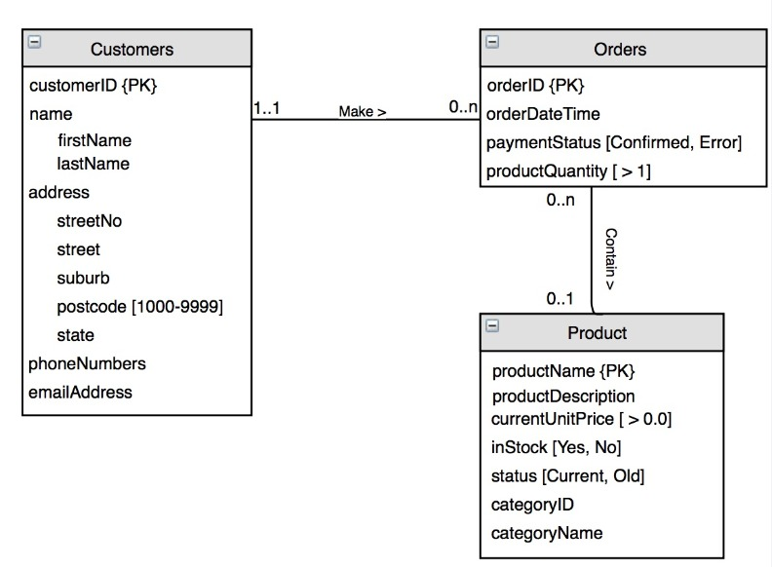

**DFD**

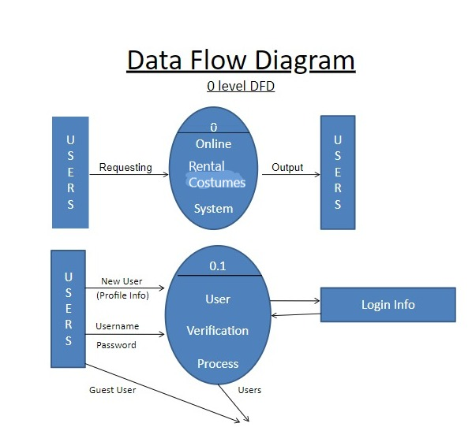

1ST Level DFD

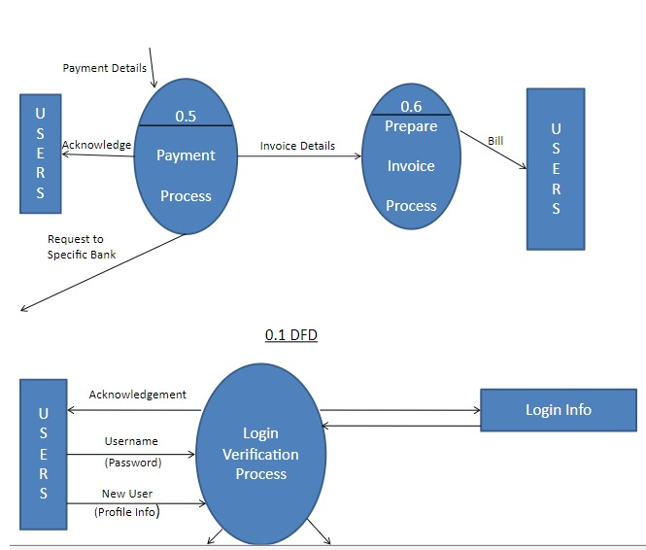

**2nd Level DFD**

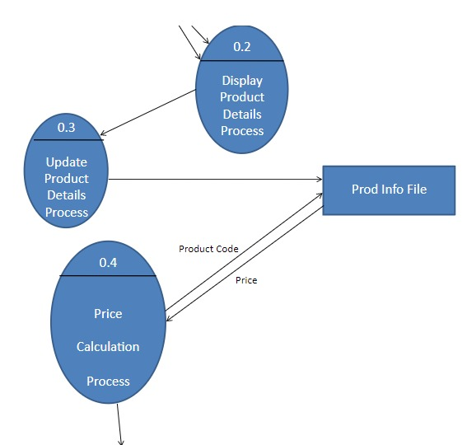

**SYSTEM AND SOFTWARE SPECIFICATION**

* Windows11 Operating System
* Frontend Languages: HTML, CSS, JavaScript
* Backend: phpMyAdmin
* Connection: PHP
* Server: xampp

**PROPOSED SYSTEM**

* Wearing a new outfit nowadays is easy because of the rental costumes. Gone are the days, when you had to save up money, month after month in order to afford high-end designer outfits or only dream about wearing a new outfit every time you go out.
* With our on-rent fashion portal, it’s now possible to rent designer and high-end luxury wear at a fraction of the price.
* This comes in handy especially when you’re attending a wedding or a special occasion and don’t want to spend a bomb on an outfit that you’re only going to wear once or when you have to look your best at an outing but have nothing to wear.
* Also, it is highly convenient as our website will pack, deliver or pick up the outfits that you order or wish to sell and also time-efficient as we aim to offer same-day delivery and pick-up of costumes to our customers.

**SYSTEM ARCHITECTURE:**

**MODULES DESCRIPTION:**

* **SIGN-UP:**

This module is designed for the user to sign up into our website. It is preliminary step that a user has to perform in order to login into our website. The respective user details will be stored in the database. User can set his username and password in this module.

* **LOGIN:**

After signing up in-order to use the facilities and services provided by our website it is mandatory for the users to login with the username and password given during signup stage. Only, if it matches with the respective details it will redirect to the home page.  If they are new users to our website, they have to sign-up using signup option provided in this page and then login.

* **HOME PAGE:**

In the homepage of our website, we provide three options namely:

* Kids
* Men
* Women

Based on the user requirement they can select any one of the above options to proceed further. To make our website user-friendly we have added Contact Us option in homepage. We provide 24/7 customer service.

* **SELL OUTFITS:**

When the user wants to sell outfits that are no longer required for them, they can sell their outfits using our website. The quality checkers will check whether the outfit is proper or not and based on that the users get access to display or project their outfit in our website and the users who have interest to purchase can purchase them.

* **PURCHASE OUTFITS:**

Users who are willing to purchase the outfits can buy the desired outfit based on their requirements using this option present in homepage. Once the user clicks on this option, he/ she will be redirected to a page where they can select the type of costume they require, they can fill their measurements details and the mode of purchase. According to the details entered, available costumes will be sorted and displayed.

* **PAYEMENT PROCESS:**

When a customer buys an outfit - after selecting the particular outfit the user can the corresponding rental amount by using this option. We provide the option namely Cash on Delivery.

* **LOGOUT:**

After successfully using our application, the user can logout using this option.

**CODE:**

**Register.php**

<?php

$active = "Register";

include("db.php");

include("functions.php");

include('header.php');

?>

<!-- Breadcrumb Section Begin -->

<div class="breacrumb-section">

<div class="container">

<div class="row">

<div class="col-lg-12">

<div class="breadcrumb-text">

<a href="Index.php"><i class="fa fa-home"></i> Home</a>

<span>Register</span>

</div>

</div>

</div>

</div>

</div>

<!-- Breadcrumb Form Section Begin -->

<!-- Register Section Begin -->

<div class="register-login-section spad">

<div class="container-fluid">

<div class="row">

<div class="col-lg-6 offset-lg-3">

<div class="register-form">

<h2>Register</h2>

<form action="register.php" method="post" enctype="multipart/form-data" id="logform">

<div class="row">

<div class="group-input col-md-6">

<label for="username">Name</label>

<input type="text" id="username" name="name" required>

<div id="nameerr" style="margin:20px 0"></div>

</div>

<div class="group-input col-md-6">

<label for="con">Contact *</label>

<input type="text" id="con" name="contact" required>

<div id="conerr" style="margin:20px 0"></div>

</div>

</div>

<div class="group-input">

<label for="email">Email *</label>

<input type="text" id="eemail" name="cemail" required>

<div id="eerr" style="margin:20px 0"></div>

</div>

<div class="group-input">

<label for="pass">Password *</label>

<input type="password" id="pass" name="password" required>

</div>

<div class="group-input">

<label for="con-pass">Address *</label>

<input type="text" id="con-pass" name="address" required>

</div>

<div class="group-input">

<label for="con-pass">Profile Image *</label>

<input type="file" name="pimage" style="border: none; margin-top:6px;" required>

</div>

<button type="submit" class="site-btn register-btn" name="register">REGISTER</button>

</form>

<div class="switch-login">

<a href="login.php" class="or-login">Or Login</a>

</div>

</div>

</div>

</div>

</div>

</div>

<!-- Register Form Section End -->

<?php

include('footer.php');

?>

<script>

$("#logform").submit(function(event) {

var name = $('#username').val();

var email = $('#eemail').val();

var con = $('#con').val();

var letters = /^[A-Za-z]+$/;

var em = /\S+@\S+\.\S+/;

var numbers = /^[0-9]{11}$/;

if (!name.match(letters)) {

$("#nameerr").html(

"<span class='alert alert-danger'>" +

"Enter Valid Name (Letters only)</span>");

event.preventDefault();

}

if (!con.match(numbers)) {

$("#conerr").html(

"<span class='alert alert-danger'>" +

"Enter Valid Contact (11 Digit)</span>");

event.preventDefault();

}

if (!email.match(em)) {

$("#eerr").html(

"<span class='alert alert-danger'>" +

"Enter Valid Email</span>");

event.preventDefault();

}

});

</script>

</body>

</html>

<?php

if (isset($_POST['register'])) {

$c_name = $_POST['name'];

$c_email = $_POST['cemail'];

$c_address = $_POST['address'];

$c_pass = $_POST['password'];

$c_contact = $_POST['contact'];

$c_name = $_POST['name'];

$c_ip = getRealIpUser();

$_SESSION['customer_email'] = $c_email;

$c_id = $_SESSION['customer_email'];

$tardir = "img/customer/";

$fileName = basename($_FILES['pimage']['name']);

$targetPath = $tardir . $fileName;

$fileType = pathinfo($targetPath, PATHINFO_EXTENSION);

$allow = array('jpg', 'png', 'jpeg');

if (in_array($fileType, $allow)) {

if (move_uploaded_file($_FILES['pimage']['tmp_name'], $targetPath)) {

$insert_c = "Insert into customer (customer_name,customer_email,customer_pass,customer_address,customer_contact,customer_image,customer_ip)

values('$c_name','$c_email','$c_pass','$c_address','$c_contact','$fileName','$c_ip')";

}

} else {

echo "<script>alert('Image not Inserted.')</script>";

}

$run_insert = mysqli_query($con, $insert_c);

$sel_cart = "select * from cart where c_id = '$c_id'";

$run_sel_cart = mysqli_query($con, $sel_cart);

$check_cart = mysqli_num_rows($run_sel_cart);

if ($check_cart > 0) {

$_SESSION['customer_email'] = $c_email;

echo "<script>alert('Account registered. You are Logged In')</script>";

echo "<script>window.open('check-out.php','_self')</script>";

} else {

$_SESSION['customer_email'] = $c_email;

echo "<script>alert('Account registered. You are Logged In')</script>";

echo "<script>window.open('index.php','_self')</script>";

}

}

?>

**Login.php**

<?php

$active = "Login";

include("db.php");

include("functions.php");

include("header.php");

?>

<!-- Breadcrumb Section Begin -->

<div class="breacrumb-section">

<div class="container">

<div class="row">

<div class="col-lg-12">

<div class="breadcrumb-text">

<a href="index.php"><i class="fa fa-home"></i> Home</a>

<span>Login</span>

</div>

</div>

</div>

</div>

</div>

<!-- Breadcrumb Form Section Begin -->

<!-- Register Section Begin -->

<div class="register-login-section spad">

<div class="container">

<div class="row">

<div class="col-lg-6 offset-lg-3">

<div class="login-form">

<h2>Login</h2>

<form action="login.php" method="post">

<div class="group-input">

<label for="username">Email *</label>

<input type="text" id="username" name="cemail" required>

<div id="email_error"></div>

</div>

<div class="group-input">

<label for="pass">Password *</label>

<input type="password" id="pass" name="password" required>

<div id="password_error"></div>

</div>

<button name="login" class="site-btn login-btn">Sign In</button>

</form>

<div class="switch-login">

<a href="register.php" class="or-login">Or Create An Account</a>

</div>

</div>

</div>

</div>

</div>

</div>

<!-- Register Form Section End -->

<?php

include('footer.php');

?>

</body>

</html>

<?php

if (isset($_POST['login'])) {

$log_email = $_POST['cemail'];

$log_pass = $_POST['password'];

$c_id = $log_email;

$sel_customer = "select * from customer where customer_email = '$log_email' AND customer_pass = '$log_pass'";

$run_sel_c = mysqli_query($con, $sel_customer);

$get_ip = getRealIpUser();

$check_customer = mysqli_num_rows($run_sel_c);

$select_cart = "select * from cart where c_id = '$c_id'";

$run_sel_cart = mysqli_query($con, $select_cart);

$check_cart = mysqli_num_rows($run_sel_cart);

if ($check_customer == 0) {

echo "

<script>

bootbox.alert({

message: 'Invalid Username or Password',

backdrop: true

});

</script>";

exit();

}

if ($check_customer == 1 and $check_cart == 0) {

$_SESSION['customer_email'] = $log_email;

echo "<script>window.open('index.php?stat=1','_self')</script>";

} else {

$_SESSION['customer_email'] = $log_email;

echo "<script>window.open('check-out.php?','_self')</script>";

}

}

?>

**Index.php**

<?php

$active = "Home";

include("functions.php");

include("header.php");

?>

<section class="hero-section">

<div class="hero-items owl-carousel">

<?php

$get_slides = "select * from slider LIMIT 0,1";

$run_slider = mysqli_query($con, $get_slides);

while ($row_slides = mysqli_fetch_array($run_slider)) {

$slide_name = $row_slides['slide_name'];

$slide_image = $row_slides['slide_image'];

$slide_heading = $row_slides['slide_heading'];

$slide_text = $row_slides['slide_text'];

echo "

<div class='single-hero-items set-bg' data-setbg='img/$slide_image'>

<div class='container'>

<div class='row'>

<div class='col-lg-5'>

<h1>$slide_heading</h1>

<p>$slide_text

</p>

<a href='shop.php' class='primary-btn'>Shop Now</a>

</div>

</div>

</div>

</div>

";

}

$get_slides = "select * from slider LIMIT 1,2";

$run_slider = mysqli_query($con, $get_slides);

while ($row_slides = mysqli_fetch_array($run_slider)) {

$slide_name = $row_slides['slide_name'];

$slide_image = $row_slides['slide_image'];

$slide_heading = $row_slides['slide_heading'];

$slide_text = $row_slides['slide_text'];

echo "

<div class='single-hero-items set-bg' data-setbg='img/$slide_image'>

<div class='container'>

<div class='row'>

<div class='col-lg-5'>

<h1 style='color: peach;'>$slide_heading</h1>

<p style='color: peach;'>$slide_text

</p>

<a href='shop.php' class='primary-btn'>Shop Now</a>

</div>

</div>

</div>

</div>";

}

?>

</div>

</section>

<!-- Banner Section Begin -->

<div class="banner-section spad">

<div class="container-fluid">

<div class="row">

<div class="col-lg-4">

<a href='shop.php?cat_id=1'>

<div class="single-banner">

<img src="img/men_1.jpg" alt="Mens">

<div class="inner-text">

<h4>Men’s</h4>

</div>

</div>

</a>

</div>

<div class="col-lg-4">

<a href='shop.php?cat_id=2'>

<div class="single-banner">

<img src="img/women_1.jpg" alt="">

<div class="inner-text">

<h4>Women’s</h4>

</div>

</div>

</a>

</div>

<div class="col-lg-4">

<a href='shop.php?cat_id=3'>

<div class="single-banner">

<img src="img/kids_3.jpg" alt="">

<div class="inner-text">

<h4>Kid’s</h4>

</div>

</div>

</a>

</div>

</div>

</div>

</div>

<!-- Women Banner Section Begin -->

<section class="women-banner spad">

<div class="container-fluid">

<div class="row">

<div class="col-lg-3">

<div class="product-large set-bg" data-setbg="img/women-large.jpg">

<h2>Women’s</h2>

<a href="shop.php?cat_id=2">Discover More</a>

</div>

</div>

<div class="col-lg-8 offset-lg-1">

<div class="filter-control">

<h3> Hot Products </h3>

</div>

<div class="product-slider owl-carousel">

<?php

getWProduct();

?>

</div>

</div>

</div>

</div>

</section>

<!-- Man Banner Section Begin -->

<section class="man-banner spad">

<div class="container-fluid">

<div class="row">

<div class="col-lg-8">

<div class="filter-control">

<h3> Hot Products </h3>

</div>

<div class="product-slider owl-carousel">

<?php

getMProduct();

?>

</div>

</div>

<div class="col-lg-3 offset-lg-1">

<div class="product-large set-bg m-large" data-setbg="img/men-large.jpg">

<h2>Men’s</h2>

<a href="shop.php?cat_id=1">Discover More</a>

</div>

</div>

</div>

</div>

</section>

<!-- Footer -->

<?php

include('footer.php');

if (isset($_GET['stat'])) {

echo "

<script>

bootbox.alert({

message: 'Welcome! You are logged in.',

backdrop: true

});

</script>";

}

?>

</body>

</html>

**Account.php**

<?php

$active = "Account";

include("db.php");

include("functions.php");

include("header.php");

?>

<!-- Breadcrumb Section Begin -->

<div class="breacrumb-section">

<div class="container">

<div class="row">

<div class="col-lg-12">

<div class="breadcrumb-text product-more">

<a href="index.php"><i class="fa fa-home"></i> Home</a>

<span>Account</span>

</div>

</div>

</div>

</div>

</div>

<!-- #content Begin -->

<div class="container">

<div class="insider row">

<div class="col-md-3 col-8" style="padding: 20px 0;">

<?php

include("sidebar.php");

?>

</div>

<div class="col-md-8 col-10" style="padding:20px 0">

<?php

if (isset($_GET['orders'])) {

echo " <h4 class='card' style='text-align: center; margin: 0 0 30px 0;font-weight:600;padding:10px 0 '>My Orders</h4>";

include("orders.php");

}

if (isset($_GET['details'])) {

echo " <h4 class='card' style='text-align: center; margin: 0 0 30px 0;font-weight:600;padding:10px 0 '>Account Details </h4>";

include("details.php");

}

?>

</div>

</div>

</div>

<?php

include('footer.php');

?>

</body>

</html>

**Check-out.php**

<?php

$active = "Checkout";

include('db.php');

include("functions.php");

include("header.php");

?>

<!-- Breadcrumb Section Begin -->

<div class="breacrumb-section">

<div class="container">

<div class="row">

<div class="col-lg-12">

<div class="breadcrumb-text product-more">

<a href="index.php"><i class="fa fa-home"></i> Home</a>

<a href="shop.php">Shop</a>

<span>Check Out</span>

</div>

</div>

</div>

</div>

</div>

<!-- Breadcrumb Section End -->

<!-- Shopping Cart Section Begin -->

<section class="checkout-section spad">

<div class="container">

<form class="checkout-form">

<div class="row">

<div class="col-lg-6" <?php if (!($_SESSION['customer_email'] == 'unset')) {

echo "style = 'margin: 0 auto'";

} ?>>

<div class="checkout-content">

<a href="shop.php" class="content-btn">Continue Shopping</a>

</div>

<div class="place-order">

<h4>Your Order</h4>

<div class="order-total">

<ul class="order-table">

<li>Products <span>Total</span></li>

<?php checkoutProds(); ?>

<li class="fw-normal">Subtotal <span><?php total_price(); ?></span></li>

<li class="total-price">Total <span><?php total_price(); ?></span></li>

</ul>

<form action="check-out.php" method="post">

<div class="order-btn">

<a href="check-out.php?place=1" class="site-btn place-btn">Place Order</a>

</div>

</form>

</div>

</div>

</div>

</form>

</div>

</section>

<!-- Shopping Cart Section End -->

<?php

include('footer.php');

?>

</body>

</html>

<?php

if (isset($_GET['place'])) {

$c_id = $_SESSION['customer_email'];

$query = "select * from customer where customer_email= '$c_id'";

$run_query = mysqli_query($con, $query);

$get_query = mysqli_fetch_array($run_query);

$custom_id = $get_query['customer_id'];

$get_items = "select * from cart where c_id = '$c_id'";

$run_items = mysqli_query($db, $get_items);

while ($row_items = mysqli_fetch_array($run_items)) {

$p_id = $row_items['products_id'];

$pro_qty = $row_items['qty'];

$get_item = "select * from products where products_id = '$p_id'";

$run_item = mysqli_query($db, $get_item);

while ($row_item = mysqli_fetch_array($run_item)) {

$pro_price = $row_item['product_price'];

$total_q += $pro_qty;

$pro_total_p = $pro_price * $pro_qty;

}

$final_price += $pro_total_p;

}

$order = "insert into orders (order_qty, order_price, c_id, date) values ('$total_q','$final_price','$custom_id',NOW())";

$run_order = mysqli_query($con, $order);

$cart_clear = "delete from cart where c_id = '$c_id'";

$run_clear = mysqli_query($con, $cart_clear);

echo "<script>alert('Order Placed. Thankyou for Shopping')</script>";

echo "<script>window.open('account.php?orders','_self')</script>";

}

?>

**Config.php**

<?php

session_start();

if (!isset($_SESSION['customer_email'])) {

$_SESSION['customer_email'] = 'unset';

} else {

return;

}

?>

**Contact.php**

<?php

$active = "Contact";

include('db.php');

include("functions.php");

include("header.php");

?>

<!-- Breadcrumb Section Begin -->

<div class="breacrumb-section">

<div class="container">

<div class="row">

<div class="col-lg-12">

<div class="breadcrumb-text">

<a href="index.php"><i class="fa fa-home"></i> Home</a>

<span>Contact</span>

</div>

</div>

</div>

</div>

</div>

<!-- Breadcrumb Section Begin -->

<!-- Contact Section Begin -->

<section class="contact-section spad">

<div class="container">

<div class="row">

<div class="col-lg-5">

<div class="contact-title">

<h4>Contacts Us</h4>

<p>Your Passion is our Satisfaction</p>

</div>

<div class="contact-widget">

<div class="cw-item">

<div class="ci-icon">

<i class="ti-location-pin"></i>

</div>

<div class="ci-text">

<span>Address:</span>

<p>NUST H-12, Chennai</p>

</div>

</div>

<div class="cw-item">

<div class="ci-icon">

<i class="ti-mobile"></i>

</div>

<div class="ci-text">

<span>Phone:</span>

<p>+92 3213352126</p>

</div>

</div>

<div class="cw-item">

<div class="ci-icon">

<i class="ti-email"></i>

</div>

<div class="ci-text">

<span>Email:</span>

<p>Costume Kingdom.@gmail.com</p>

</div>

</div>

</div>

</div>

<div class="col-lg-6 offset-lg-1">

<div class="contact-form">

<div class="leave-comment">

<h4>Leave A Message</h4>

<p>Our staff will call back later and answer your questions.</p>

<form action="contact.php" class="comment-form">

<div class="row">

<div class="col-lg-6">

<input type="text" placeholder="Your name" class="form-control" name="name" required>

</div>

<div class="col-lg-6">

<input type="text" placeholder="Your email" class="form-control" name="email" required>

</div>

<div class="col-lg-12">

<input type="text" placeholder="Message Subject" class="form-control" name="subject" required>

</div>

<div class="col-lg-12">

<textarea placeholder="Your message" class="form-control" name="message"></textarea>

<button class="site-btn" name="submit">Send message</button>

</div>

</div>

</form>

<?php

if (isset($_POST['submit'])) {

$user_name = $_POST['name'];

$user_email = $_POST['email'];

$user_subject = $_POST['subject'];

$user_msg = $_POST['message'];

$receiver_mail = 'yousafsaddique523@gmail.com';

mail($receiver_mail, $user_name, $user_subject, $user_msg, $user_email);

}

?>

</div>

</div>

</div>

</div>

</div>

</section>

<!-- Contact Section End -->

<?php

include('footer.php');

?>

</body>

</html>

**Db.php**

<?php

$con = mysqli_connect("localhost","root", "", "threaderz_store");

?>

**Details.php**

<?php

$active = "Details";

if (isset($_GET['details'])) {

$emal = $_SESSION['customer_email'];

$query = "select * from customer where customer_email = '$emal'";

$run_query = mysqli_query($con,$query);

$row_query = mysqli_fetch_array($run_query);

$cname = $row_query['customer_name'];

$cemail = $row_query['customer_email'];

$ccontact = $row_query['customer_contact'];

$cpass = $row_query['customer_pass'];

$caddress = $row_query['customer_address'];

echo "

<div class='col-md-6 col-12' style='margin:0px auto'>

<div class='bg-light text-dark' style='border:solid #e5e5e5 0.2px; padding: 10px 40px'>

<div class='ci-text'>

<span style='font-size:large;font-weight:600'>Email</span>

<p style='text-align:center'>$cemail</p>

</div>

<div class='ci-text'>

<span style='font-size:large;font-weight:600'>Contact</span>

<p style='text-align:center'>$ccontact</p>

</div>

<div class='ci-text'>

<span style='font-size:large;font-weight:600'>Address</span>

<p style='text-align:center'>$caddress</p>

</div>

</div>

</div>

";

}

**Footer.php**

<!-- Footer Section Begin -->

<footer class="footer-section">

<div class="container">

<div class="row" style="padding-bottom: 40px;">

<div class="col-lg-3">

<div class="footer-left">

<div class="footer-logo">

<a href="index.php"> <span>Costume Kingdom</span>

</a>

</div>

<ul>

<li>Copy Rights:</li>

<li>Sheral</li>

<li> Pravalika</li>

<li> Yasaswini </li>

<li>Costume Kingdom@gmail.com</li>

<li>R.T Road, Plot.No: 32415, Chennai</li>

</ul>

<div class="footer-social">

<a href="https://www.facebook.com/" target="_blank"><i class="fa fa-facebook"></i></a>

<a href="https://www.instagram.com/?hl=en" target="_blank"><i class="fa fa-instagram"></i></a>

<a href="https://twitter.com/explore" target="_blank"><i class="fa fa-twitter"></i></a>

<a href="https://www.pinterest.com/" target="_blank"><i class="fa fa-pinterest"></i></a>

</div>

</div>

</div>

<div class="col-lg-2 offset-lg-1">

<div class="footer-widget">

<h5>Information</h5>

<ul>

<li><a href="index.php">About Us</a></li>

<li><a href="contact.php">Contact</a></li>

<li><a href="index.php">Privacy Policy</a></li>

</ul>

</div>

</div>

<div class="col-lg-2">

<div class="footer-widget" style="display: <?php if ($active == 'Register' || $active == 'Login') {

echo 'none';

}; ?>;">

<h5>Account</h5>

<ul>

<?php if (!($_SESSION['customer_email'] == 'unset')) {

echo "<li><a href='account.php?orders'>My Account</a></li>";

} ?>

<li><a href="

<?php if (!($_SESSION['customer_email'] == 'unset')) {

echo "shopping-cart.php";

} else {

echo "login.php";

}

?>">Shopping Cart</a></li>

<li><a href="

<?php if (!($_SESSION['customer_email'] == 'unset')) {

echo "check-out.php";

} else {

echo "login.php";

}

?>

">Check Out</a></li>

</ul>

</div>

</div>

<div class="col-lg-4">

<div class="newslatter-item">

<h5>Keep in touch</h5>

<p>Get E-mail updates about our latest special offers.</p>

<form action="index.php" class="subscribe-form">

<input type="text" placeholder="Enter Your Mail">

<button type="button">Subscribe</button>

</form>

</div>

</div>

</div>

</div>

</footer>

<script src="js/jquery-3.3.1.min.js"></script>

<script src="https://cdnjs.cloudflare.com/ajax/libs/popper.js/2.4.4/umd/popper.min.js" integrity="sha512-eUQ9hGdLjBjY3F41CScH3UX+4JDSI9zXeroz7hJ+RteoCaY+GP/LDoM8AO+Pt+DRFw3nXqsjh9Zsts8hnYv8/A==" crossorigin="anonymous"></script>

<script src="js/bootstrap.min.js"></script>

<script src="js/jquery.zoom.min.js"></script>

<script src="https://cdnjs.cloudflare.com/ajax/libs/bootbox.js/5.4.0/bootbox.min.js" integrity="sha512-8vfyGnaOX2EeMypNMptU+MwwK206Jk1I/tMQV4NkhOz+W8glENoMhGyU6n/6VgQUhQcJH8NqQgHhMtZjJJBv3A==" crossorigin="anonymous"></script>

<script src="js/jquery.slicknav.js"></script>

<script src="js/owl.carousel.min.js"></script>

<script src="js/main.js"></script>

**Functions.php**

<?php

$db = mysqli_connect('localhost', 'root', '', 'threaderz_store');

function getRealIpUser()

{

switch (true) {

case (!empty($_SERVER['HTTP_X_REAL_IP'])):

return $_SERVER['HTTP_X_REAL_IP'];

case (!empty($_SERVER['HTTP_CLIENT_IP'])):

return $_SERVER['HTTP_CLIENT_IP'];

case (!empty($_SERVER['HTTP_X_FORWARDED_FOR'])):

return $_SERVER['HTTP_X_FORWARDED_FOR'];

default:

return $_SERVER['REMOTE_ADDR'];

}

}

function addCart()

{

global $db;

if (isset($_GET['add_cart'])) {

$ip_add = getRealIpUser();

$c_id = $_SESSION['customer_email'];

$p_id = $_GET['add_cart'];

$qty = $_POST['product_qty'];

$size = $_POST['size'];

$check_product = "select * from cart where c_id = '$c_id' AND products_id = '$p_id'";

$run_check = mysqli_query($db, $check_product);

if (mysqli_num_rows($run_check) > 0) {

echo "<script>alert('Product already added.')</script>";

echo "<script>window.open('product.php?pro_id=$p_id','_self')</script>";

} else {

$query = "Insert into cart (products_id, ip_add,qty,size,date,c_id) values('$p_id','$ip_add','$qty','$size',NOW(),'$c_id')";

$run_query = mysqli_query($db, $query);

echo "<script>alert('Product added to Cart. Keep Shopping.')</script>";

echo "<script>window.open('product.php?product_id=$p_id','_self')</script>";

}

}

}

// Retrieve Women Products for index slider

function getWProduct()

{

global $db;

$get_products = "select * from products where cat_id=2 order by RAND() LIMIT 7";

$run_products = mysqli_query($db, $get_products);

while ($row_products = mysqli_fetch_array($run_products)) {

$products_id = $row_products['products_id'];

$product_title = $row_products['product_title'];

$product_price = $row_products['product_price'];

$product_img1 = $row_products['product_img1'];

echo "

<div class='product-item'>

<div class='pi-pic' style='max-height:300px'>

<img src='img/products/$product_img1' alt='$product_title'>

<ul>

<li class='quick-view'><a href='product.php?product_id=$products_id' style='background:#fe4231;color:white'>View Details</a></li>

</ul>

</div>

<div class='pi-text'>

<a href='product.php?product_id=$products_id'>

<h5>$product_title</h5>

</a>

<div class='product-price'>

INR $product_price

</div>

</div>

</div>

";

}

}

// Retrieve men Products for index slider

function getMProduct()

{

global $db;

$get_products = "select * from products where cat_id=1 order by RAND() LIMIT 7";

$run_products = mysqli_query($db, $get_products);

while ($row_products = mysqli_fetch_array($run_products)) {

$products_id = $row_products['products_id'];

$product_title = $row_products['product_title'];

$product_price = $row_products['product_price'];

$product_img1 = $row_products['product_img1'];

echo "

<div class='product-item'>

<div class='pi-pic' style='max-height:300px'>

<img src='img/products/$product_img1' alt='$product_title'>

<ul>

<li class='quick-view'><a href='product.php?product_id=$products_id' style='background:#fe4231;color:white'>View Details</a></li>

</ul>

</div>

<div class='pi-text'>

<a href='#'>

<h5>$product_title</h5>

</a>

<div class='product-price'>

INR $product_price

</div>

</div>

</div>

";

}

}

// Retrieve Products Catergories

function getProdCat()

{

global $db;

$get_p_cats = "select * from product_categories";

$run_p_cats = mysqli_query($db, $get_p_cats);

while ($row_p_cats = mysqli_fetch_array($run_p_cats)) {

$p_cat_id = $row_p_cats['p_cat_id'];

$p_cat_title = $row_p_cats['p_cat_title'];

echo "

<li><a href='shop.php?p_cat_id=$p_cat_id'>$p_cat_title</a></li>

";

}

}

// Retrieve Catergories

function getCat()

{

global $db;

$get_cats = "select * from category";

$run_cats = mysqli_query($db, $get_cats)

while ($row_cats = mysqli_fetch_array($run_cats)) {

$cat_id = $row_cats['cat_id'];

$cat_title = $row_cats['cat_title'];

echo "

<li class='hovclass'><a href='shop.php?cat_id=$cat_id'>$cat_title</a></li>

";

}

}

function getPcatProd()

{

global $db;

if (isset($_GET['p_cat_id'])) {

$p_cat_id = $_GET['p_cat_id'];

$get_p_cat = "select * from product_categories where p_cat_id='$p_cat_id'";

$run_p_cat = mysqli_query($db, $get_p_cat);

$row_p_cat = mysqli_fetch_array($run_p_cat);

$p_cat_title = $row_p_cat['p_cat_title'];

$p_cat_desc = $row_p_cat['p_cat_desc'];

$get_products = "select * from products where p_cat_id='$p_cat_id'";

$run_products = mysqli_query($db, $get_products);

$count = mysqli_num_rows($run_products);

if ($count == 0) {

echo "

<div class='card' style='font-weight:bold; color:#fe4231'>

<div class='card-body'>No Products Available</div>

</di

";

} else {

while ($row_products = mysqli_fetch_array($run_products)) {

$products_id = $row_products['products_id'];

$product_title = $row_products['product_title'];

$product_price = $row_products['product_price'];

$product_img1 = $row_products['product_img1'];

echo "

<div class='col-lg-4 col-sm-6'>

<div class='product-item'>

<div class='pi-pic' style='max-height:350px'>

<img src='img/products/$product_img1' alt='$product_title'>

<ul>

<li class='quick-view'><a href='product.php?product_id=$products_id' style='background:#fe4231;color:white'>View Details</a></li>

</ul>

</div>

<div class='pi-text'>

<div class='catagory-name'></div>

<a href='product.php?product_id=$products_id'>

<h5>$product_title</h5>

</a>

<div class='product-price'>

INR $product_price

</div>

</div>

</div>

</div>

";

}

}

}

}

function getcatProd()

{

global $db;

if (isset($_GET['cat_id'])) {

$cat_id = $_GET['cat_id'];

$get_cat = "select * from category where cat_id='$cat_id'";

$run_cat = mysqli_query($db, $get_cat);

$row_cat = mysqli_fetch_array($run_cat);

$p_cat_title = $row_cat['cat_title'];

$p_cat_desc = $row_cat['cat_desc'];

$get_products = "select * from products where cat_id='$cat_id'";

$run_products = mysqli_query($db, $get_products);

$count = mysqli_num_rows($run_products);

if ($count == 0) {

echo "

<div class='card' style='font-weight:bold; color:#fe4231'>

<div class='card-body'>No Products Available</div>

</div>

";

} else {

while ($row_products = mysqli_fetch_array($run_products)) {

$products_id = $row_products['products_id'];

$product_title = $row_products['product_title'];

$product_price = $row_products['product_price'];

$product_img1 = $row_products['product_img1'];

echo "

<div class='col-lg-4 col-sm-6'>

<div class='product-item'>

<div class='pi-pic' style='max-height:350px'>

<img src='img/products/$product_img1' alt='$product_title'>

<ul>

<li class='quick-view'><a href='product.php?product_id=$products_id' style='background:#fe4231;color:white'>View Details</a></li>

</ul>

</div>

<div class='pi-text'>

<div class='catagory-name'></div>

<a href='product.php?product_id=$products_id'>

<h5>$product_title</h5>

</a>

<div class='product-price'>

INR $product_price

</div>

</div>

</div>

</div>

";

}

}

}

}

function getProd()

{

global $db;

if (isset($_GET['product_id'])) {

$product_id = $_GET['product_id'];

$get_product_id = "select * from products where products_id='$product_id'";

$run_product_id = mysqli_query($db, $get_product_id);

$row_products = mysqli_fetch_array($run_product_id);

$product_title = $row_products['product_title'];

$product_price = $row_products['product_price'];

$product_desc = $row_products['product_desc'];

$product_img1 = $row_products['product_img1'];

$product_img2 = $row_products['product_img2'];

$get_p_cat_name = "select p_cat_title from products as P,product_categories as C where P.p_cat_id=C.p_cat_id and products_id=$product_id";

$run_get_p_cat_name = mysqli_query($db, $get_p_cat_name);

$row_p_cat_name = mysqli_fetch_array($run_get_p_cat_name);

$p_cat_name = $row_p_cat_name['p_cat_title'];

echo "

<div class='col-lg-6' style='margin:0 auto'>

<div class='product-pic-zoom col-md-8' style='max-height:400px;margin: 0 0 30px 0'>

<img class='product-big-img' src='img/products/$product_img1' alt='$product_title'>

<div class='zoom-icon'>

<i class='fa fa-search-plus'></i>

</div>

</div>

<div class='product-thumbs'>

<div class='product-thumbs-track ps-slider owl-carousel'>

<div class='pt active' data-imgbigurl='img/products/$product_img1'><img src='img/products/$product_img1' alt='$product_title'></div>

<div class='pt' data-imgbigurl='img/products/$product_img2'><img src='img/products/$product_img2' alt='$product_title'></div>

</div>

</div>

</div>

<div class='col-lg-6'>

<div class='product-details'>

<div class='pd-title'>

<h3>$product_title</h3>

</div>

<div class='pd-desc'>

<p>$product_desc</p>

<h4>INR $product_price</h4>

</div>

<ul class='pd-tags'>

<li><span>CATEGORY</span>: $p_cat_name</li>

</ul>

";

}

}

function relatedProducts()

{

global $db;

if (isset($_GET['product_id'])) {

$product_id = $_GET['product_id'];

$get_p_cat_id = "select C.p_cat_id,C.p_cat_title from products as P,product_categories as C where P.p_cat_id=C.p_cat_id and products_id=$product_id";

$run_get_p_cat_id = mysqli_query($db, $get_p_cat_id);

$row_p_cat_id = mysqli_fetch_array($run_get_p_cat_id);

$pcat_id = $row_p_cat_id['p_cat_id'];

$get_r_products = "select * from products where p_cat_id=$pcat_id LIMIT 1,4";

$run_get_r_products = mysqli_query($db, $get_r_products);

while ($row_get_r_products = mysqli_fetch_array($run_get_r_products)) {

$p_id = $row_get_r_products['products_id'];

$p_name = $row_get_r_products['product_title'];

$p_img1 = $row_get_r_products['product_img1'];

$p_price = $row_get_r_products['product_price'];

if ($p_id != $product_id) {

echo "

<div class='col-lg-3 col-sm-6'>

<div class='product-item' >

<div class='pi-pic' style='max-height:300px'>

<img src='img/products/$p_img1' alt='$p_name'>

<ul>

<li class='quick-view'><a href='product.php?product_id=$p_id' style='background:#fe4231;color:white'>View Details</a></li>

</ul>

</div>

<div class='pi-text'>

<a href='#'>

<h5>$p_name</h5>

</a>

<div class='product-price'>

INR $p_price

</div>

</div>

</div>

</div>

";

}

}

}

}

function items()

{

global $db;

$ip_add = getRealIpUser();

$c_id = $_SESSION['customer_email'];

$get_items = "select * from cart where c_id = '$c_id'";

$run_items = mysqli_query($db, $get_items);

$count_items = mysqli_num_rows($run_items);

echo $count_items;

}

function total_price()

{

global $db;

$ip_add = getRealIpUser();

$c_id = $_SESSION['customer_email'];

$total = 0;

$get_items = "select * from cart where c_id = '$c_id'";

$run_items = mysqli_query($db, $get_items);

while ($row_items = mysqli_fetch_array($run_items)) {

$p_id = $row_items['products_id'];

$pro_qty = $row_items['qty'];

$get_price = "select * from products where products_id = '$p_id'";

$run_price = mysqli_query($db, $get_price);

while ($row_price = mysqli_fetch_array($run_price)) {

$sub_price = $row_price['product_price'] * $pro_qty;

$total += $sub_price;

}

}

echo "INR " . $total;

}

$countrows = 0;

function cart_items()

{

global $db;

$c_id = $_SESSION['customer_email'];

$get_items = "select * from cart where c_id = '$c_id' ORDER BY date DESC";

$run_itemss = mysqli_query($db, $get_items);

$countrows = mysqli_num_rows($run_itemss);

if ($countrows == 0) {

echo "

<div class='card col-md-3 col-10' style='margin:0 auto; border-radius:25px 5px;box-shadow: inset -12px -8px 40px #e5e5e5;'>

<div class='card-body'>

<h5 style='text-align:center;font-weight:500'> No items in Cart </h5>

</div>

</div>

";

} else {

echo "

<thead style='font-size: larger;'>

<tr>

<th>Image</th>

<th class='p-name'>Product Name</th>

<th>Price</th>

<th>Quantity</th>

<th>Total</th>

<th></th>

</tr>

</thead>

";

while ($row_items = mysqli_fetch_array($run_itemss)) {

$p_id = $row_items['products_id'];

$pro_qty = $row_items['qty'];

$get_item = "select * from products where products_id = '$p_id'";

$run_item = mysqli_query($db, $get_item);

while ($row_item = mysqli_fetch_array($run_item)) {

$pro_id = $row_item['products_id'];

$pro_name = $row_item['product_title'];

$pro_price = $row_item['product_price'];

$pro_img1 = $row_item['product_img1'];

$pro_total_p = $pro_price * $pro_qty;

}

echo "

<tr style='border-bottom: 0.5px solid #ebebeb'>

<td class='cart-pic first-row'><img src='img/products/$pro_img1' alt='$pro_name' style='max-height:100px'></td>

<td class='cart-title first-row'>

<h5><a href='product.php?product_id=$pro_id' style='color:black;font-weight:bold'>$pro_name</h5>

</td>

<td class='p-price first-row'>INR $pro_price</td>

<td class='qua-col first-row'>

<div class='quantity'>

<div class='pro-qty'>

<input id = 'qqty' type='text' value='$pro_qty'>

</div>

</div>

</td>

<td class='total-price first-row'>INR $pro_total_p</td>

<td class='close-td first-row'><a href='shopping-cart.php?del=$pro_id'><i class='ti-close' style='color:black'></i></a></td>

</tr>

";

}

}

}

function cart_icon_prod()

{

global $db;

$c_id = $_SESSION['customer_email'];

$ip_add = getRealIpUser();

$get_items = "select * from cart where c_id = '$c_id' ORDER BY date DESC LIMIT 0,2";

$run_items = mysqli_query($db, $get_items);

if (mysqli_num_rows($run_items) == 0) {

echo "

<p style='text-align:center; font-weight:500;color:#fe4231'>Cart Empty </p>

";

} else {

while ($row_items = mysqli_fetch_array($run_items)) {

$p_id = $row_items['products_id'];

$pro_qty = $row_items['qty'];

$get_item = "select * from products where products_id = '$p_id' ORDER BY date DESC";

$run_item = mysqli_query($db, $get_item);

while ($row_item = mysqli_fetch_array($run_item)) {

$pro_name = $row_item['product_title'];

$pro_price = $row_item['product_price'];

$pro_img1 = $row_item['product_img1'];

$pro_total_p = $pro_price * $pro_qty;

}

echo "

<tr>

<td class='si-pic'><img src='img/products/$pro_img1' alt='$pro_name' style='max-height:70px'></td>

<td class='si-text'>

<div class='product-selected'>

<p>INR $pro_price x $pro_qty</p>

<h6>$pro_name</h6>

</div>

</td>

<td class='si-close'>

<a href='shopping-cart.php?delcart=$p_id'> <i class='ti-close' style='color:black'></i></a>

</td>

</tr>

";

}

}

}

function checkoutProds()

{

global $db;

$ip_add = getRealIpUser();

$c_id = $_SESSION['customer_email'];

$get_items = "select * from cart where c_id = '$c_id' ORDER BY date DESC";

$run_items = mysqli_query($db, $get_items);

if (mysqli_num_rows($run_items) == 0) {

echo "

<li class='fw-normal' style='text-align:center;font-weight:bold;font-size:larger;color:#fe4231'>No Items in Cart</li>

";

} else {

while ($row_items = mysqli_fetch_array($run_items)) {

$p_id = $row_items['products_id'];

$pro_qty = $row_items['qty'];

$get_item = "select * from products where products_id = '$p_id' ORDER BY date DESC";

$run_item = mysqli_query($db, $get_item);

while ($row_item = mysqli_fetch_array($run_item)) {

$pro_name = $row_item['product_title'];

$pro_price = $row_item['product_price'];

$pro_total_p = $pro_price * $pro_qty;

}

echo "

<li class='fw-normal'>$pro_name x $pro_qty <span>$pro_total_p</span></li>

";

}

}

}

**Header.php**

<?php

require_once('config.php');

include('db.php');

?>

<!DOCTYPE html>

<html lang="en">

<meta charset="UTF-8">

<meta name="description" content="Costume Kingdom">

<meta name="viewport" content="width=device-width, initial-scale=1.0">

<title>Costume Kingdom</title>

<!-- Google Fonts Used -->

<link href="https://fonts.googleapis.com/css?family=Muli:300,400,500,600,700,800,900&display=swap" rel="stylesheet">

<link href='https://fonts.googleapis.com/css?family=Sofia' rel='stylesheet'>

<!-- Tab Icon -->

<link rel="icon" href="img/icon.svg">

<!-- Css Styles -->

<link rel='stylesheet' href='css/bootstrap.min.css' type='text/css'>

<link rel='stylesheet' href='css/font-awesome.min.css' type='text/css'>

<link rel='stylesheet' href='css/themify-icons.css' type='text/css'>

<link rel='stylesheet' href='css/elegant-icons.css' type='text/css'>

<link rel='stylesheet' href='css/owl.carousel.min.css' type='text/css'>

<link rel='stylesheet' href='css/slicknav.min.css' type='text/css'>

<link rel='stylesheet' href='css/style.css' type='text/css'>

</head>

<body>

<!-- Page Pre Load Section-->

<div id="preload">

<div class="load">

</div>

</div>

<!-- Header Section-->

<header class="header-section">

<!-- Top Bar -->

<div class="header-top" id="top">

<div class="container">

<div class="f-left">

<div class="top-social">

<a href="https://www.facebook.com/" target="_blank"><i class="ti-facebook"></i></a>

<a href="https://twitter.com/explore" target="_blank"><i class="ti-twitter-alt"></i></a>

<a href="https://www.instagram.com/?hl=en" target="_blank"><i class="ti-instagram"></i></a>

</div>

</div>

<div class="f-right">

<ul class="nav-right">

<li class="user-icon">

<div class="login-panel">

<i class="fa fa-user" style="font-size:20px"></i>

</div>

<div class="login-hover">

<div class="insidelog">

<?php if ($_SESSION['customer_email'] == 'unset') {

echo "<a href='login.php' class='btn logbtn' style='width: 200px; height:40px'>Login</a>";

} else {

echo "<a href='logout.php' class='btn logbtn' style='width: 200px; height:40px'>Log Out</a>";

} ?>

</div>

<?php if ($_SESSION['customer_email'] == 'unset') {

echo "<div class='insidelog'>

<span class='small'>or </span><a href='register.php' class='small'>Sign up Now</a>

</div>";

} ?>

<?php if (!($_SESSION['customer_email'] == 'unset')) {

echo "

<div class='insidelog' style='border-top: solid 0.2px #e5e5e5;'>

<a href='account.php?orders' class='btn btn-dark' style='color:white;margin:4px 0'>My Account</a>

</div>";

}

?>

</div>

</li>

</ul>

</div>

</div>

</div>

<!-- Middle Bar -->

<div class="container">

<div class="inner-header">

<div class="row">

<div class="col-md-3 logo">

<a href="index.php">

<span>Costume Kingdom</span>

</a>

</div>

<div class="col-md-6">

<form method="post">

<div class="input-group">

<input type="text" name="search" placeholder="Search our Store" required>

<button type="submit" name="submit"><i class="ti-search"></i></button>

</div>

</form>

</div>

<div class="col-md-3 text-right" style="visibility: <?php if ($_SESSION['customer_email'] == 'unset') {

echo "hidden";

} ?>">

<ul class="nav-right">

<li class="cart-icon">

<a href="shopping-cart.php">

<i class="icon_bag_alt"></i>

<span><?php items(); ?></span>

</a>

<div class="cart-hover">

<div class="select-items">

<table>

<tbody>

<?php cart_icon_prod(); ?>

</tbody>

</table>

</div>

<div class="select-total">

<span>total:</span>

<h5><?php total_price(); ?></h5>

</div>

<div class="select-button">

<a href="shopping-cart.php" class="primary-btn view-card">VIEW ALL ITEMS</a>

<a href="check-out.php" class="primary-btn checkout-btn">CHECK OUT</a>

</div>

</div>

</li>

<li class="cart-price"><?php total_price(); ?></li>

</ul>

</div>

</div>

</div>

</div>

<!-- Lower Bar -->

<div class="nav-item">

<div class="container">

<div class="nav-depart">

<div class="depart-btn">

<i class="ti-menu"></i>

<span>All Categories</span>

<ul class="depart-hover">

<?php

getProdCat();

?>

</ul>

</div>

</div>

<nav class="nav-menu mobile-menu">

<ul>

<li class="<?php if ($active == 'Home') echo "active" ?>"><a href="index.php">Home</a></li>

<li class="<?php if ($active == 'Shop') echo "active" ?>"><a href="shop.php">Shop</a></li>

<li class="<?php if ($active == 'Contact') echo "active" ?>"><a href="contact.php">Contact</a></li>

</ul>

</nav>

<div id="mobile-menu-wrap"></div>

</div>

</div>

</header>

<!-- Header End -->

<?php

if (isset($_GET['delcart'])) {

$p_id = $_GET['delcart'];

$query = "Delete from cart where products_id='$p_id'";

$run_query = mysqli_query($con, $query);

echo "<script>window.open('index.php','_self')</script>";

}

if (isset($_POST['submit'])) {

$item = $_POST["search"];

$get_product = "select * from products where product_title LIKE '%$item%' LIMIT 0,1";

$run_product = mysqli_query($con, $get_product);

$count = mysqli_num_rows($run_product);

if ($count > 0) {

$row_product = mysqli_fetch_array($run_product);

$products_id = $row_product['products_id'];

echo "<script>window.open('product.php?product_id=$products_id','_self')</script>";

} else {

echo "

<script>

bootbox.alert({

message: 'No product found',

backdrop: true

});

</script>";

}

}

?>

**Orders.php**

<?php

if (isset($_SESSION['customer_email'])) {

$c_id = $_SESSION['customer_email'];

$query = "select * from customer where customer_email= '$c_id'";

$run_query = mysqli_query($con, $query);

$get_query = mysqli_fetch_array($run_query);

$custom_id = $get_query['customer_id'];

$get_items = "select * from orders where c_id = '$custom_id' ORDER BY date DESC";

$run_items = mysqli_query($db, $get_items);

echo "

<div class='cart-table' style='min-height: 150px;'>

<table>

<thead style='font-size: larger;'>

<tr>

<th>Order ID</th>

<th>Price</th>

<th> Quantity</th>

<th>Date</th>

</tr>

</thead>

<tbody>

";

while ($row_items = mysqli_fetch_array($run_items)) {

$o_id = $row_items['order_id'];

$o_qty = $row_items['order_qty'];

$o_price = $row_items['order_price'];

$o_date = $row_items['date'];

echo

"<tr style='border-bottom: 0.5px solid #ebebeb'>

<td class='first-row'>$o_id</td>

<td class='first-row'>

$o_price

</td>

<td class='first-row'>$o_qty</td>

<td class='first-row'>

$o_date

</td>

</tr>";

}

}

?>

</tbody>

</table>

</div>

**Product.php**

<?php

$active = "Product";

include("db.php");

include("functions.php");

include('header.php');

?>

<div style="overflow: hidden;">

<!-- Breadcrumb Section Begin -->

<div class="breacrumb-section">

<div class="container">

<div class="row">

<div class="col-lg-12">

<div class="breadcrumb-text product-more">

<a href="index.php"><i class="fa fa-home"></i> Home</a>

<a href="shop.php">Shop</a>

<span>Details</span>

</div>

</div>

</div>

</div>

</div>

<!-- Breadcrumb Section Begin -->

<!-- Product Shop Section Begin -->

<section class="product-shop spad page-details">

<div class="container">

<div class="row">

<div class="col-lg-3">

<div class="filter-widget">

<h4 class="fw-title">Categories</h4>

<ul class="filter-catagories">

<?php

getCat();

?>

</ul>

</div>

</div>

<div class="col-lg-9">

<div class="row">

<?php

getProd();

addCart();

?>

<form action='product.php?add_cart=<?php if (isset($_GET['product_id'])) {

$product_id = $_GET['product_id'];

echo $product_id;

} ?>' method='post'>

<div class="form-group">

<!-- form-group Begin -->

<div class='quantity'>

<div class='pro-qty'>

<input type='text' value='1' name="product_qty">

</div>

</div>

</div><!-- form-group Finish -->

<div class="form-group">

<!-- form-group Begin -->

<div class='pd-size-choose'>

<div class='sc-item'>

<input type='radio' id='sm-size' class="form-control" name='size' value="Small" required novalidate>

<label for='sm-size'>s</label>

</div>

<div class='sc-item'>

<input type='radio' id='md-size' class="form-control" name='size' value="Medium">

<label for='md-size'>m</label>

</div>

<div class='sc-item'>

<input type='radio' id='lg-size' class="form-control" name='size' value="Large">

<label for='lg-size'>l</label>

</div>

<div class='sc-item'>

<input type='radio' id='xl-size' class="form-control" name='size' value="XL">

<label for='xl-size'>xl</label>

</div>

</div>

<p id="msg"></p>

</div><!-- form-group Finish -->

<?php if ($_SESSION['customer_email'] == 'unset') {

echo "<a href='login.php' class='btn primary-btn pd-cart' style='margin-top: 20px;'> Add to cart</a>";

} else {

echo "<button class='btn primary-btn pd-cart' id='cartbtn' style='margin-top: 20px;'> Add to cart</button>";

}

?>

</form>

</div>

</div>

</div>

</div>

</div>

</section>

<div class="related-products spad">

<div class="container">

<div class="row">

<div class="col-lg-12">

<div class="section-title">

<h2>More like this</h2>

</div>

</div>

</div>

<div class="row">

<?php

relatedProducts();

?>

</div>

</div>

</div>

</div>

<?php

include('footer.php');

?>

<script>

$("#cartbtn").on('click', function() {

var atLeastOneChecked = false;

if (!$("input[name='size']").is(':checked')) {

$("#msg").html(

"<span class='alert alert-danger'>" +

"Please Choose Size </span>");

} else {

return;

}

});

</script>

</body>

</html>

**Shop.php**

<?php

$active = "Shop";

include("functions.php");

include("header.php");

?>

<!-- Breadcrumb Section Begin -->

<div class="breacrumb-section">

<div class="container">

<div class="row">

<div class="col-lg-12">

<div class="breadcrumb-text">

<a href="index.php"><i class="fa fa-home"></i> Home</a>

<a href="shop.php">Shop</a>

<?php

if (isset($_GET['p_cat_id'])) {

$p_cat_id = $_GET['p_cat_id'];

$get_p_cat = "select * from product_categories where p_cat_id='$p_cat_id'";

$run_p_cat = mysqli_query($db, $get_p_cat);

$row_p_cat = mysqli_fetch_array($run_p_cat);

$p_cat_title = $row_p_cat['p_cat_title'];

echo " <span>$p_cat_title</span> ";

}

?>

</div>

</div>

</div>

</div>

</div>

<!-- Product Shop Section Begin -->

<section class="product-shop spad">

<div class="container">

<div class="row">

<div class="col-lg-3 col-md-6 col-sm-8 order-2 order-lg-1 produts-sidebar-filter">

<div class="filter-widget">

<h4 class="fw-title">Categories</h4>

<ul class="filter-catagories">

<?php

getCat();

?>

</ul>

</div>

</div>

<div class="col-lg-9 order-1 order-lg-2">

<div class="product-list">

<div class="row">

<?php

if (!isset($_GET['p_cat_id'])) {

if (!isset($_GET['cat_id'])) {

$per_page = 6;

if (isset($_GET['page'])) {

$page = $_GET['page'];

} else {

$page = 1;

}

$start_from = ($page - 1) * $per_page;

$get_products = "select * from products order by 1 DESC LIMIT $start_from,$per_page";

$run_products = mysqli_query($con, $get_products);

while ($row_products = mysqli_fetch_array($run_products)) {

$products_id = $row_products['products_id'];

$product_title = $row_products['product_title'];

$product_price = $row_products['product_price'];

$product_img1 = $row_products['product_img1'];

echo "

<div class='col-lg-4 col-sm-6'>

<div class='product-item'>

<div class='pi-pic' style='max-height:350px'>

<img src='img/products/$product_img1' alt='$product_title'>

<ul>

<li class='quick-view'><a href='product.php?product_id=$products_id' style='background:#fe4231;color:white'>View Details</a></li>

</ul>

</div>

<div class='pi-text'>

<div class='catagory-name'></div>

<a href='product.php?product_id=$products_id'>

<h5>$product_title</h5>

</a>

<div class='product-price'>

INR $product_price

</div>

</div>

</div>

</div>

";

}

?>

</div>

<div class="row" style="display:flex;justify-content:center; padding:14px">

<ul class="pagination">

<?php

$query = "select * from products";

$result = mysqli_query($con, $query);

$total_records = mysqli_num_rows($result);

$total_pages = ($total_records / $per_page);

$total_pages = ceil($total_pages);

if ($total_pages <= 1) {

echo "";

} else {

echo "

<li class='page-item'>

<a class='page-link' href='shop.php?page=1'>

First

</a>

</li>

";

for ($i = 2; $i < $total_pages; $i++) {

echo "

<li class='page-item'><a class='page-link' href='shop.php?page=" . $i . "'>" . $i . "</a></li>

";

}

echo "

<li class='page-item'>

<a class='page-link' href='shop.php?page=$total_pages'>

Last

</a>

</li>

";

}

}

}

?>

</ul>

</div>

<div class="row">

<?php

getPcatProd();

getcatProd();

?>

</div>

</div>

</div>

</div>

</section>

<?php

include('footer.php');

?>

</body>

</html>

**Shopping-cart.php**

<?php

$active = "Shopping Cart";

include("db.php");

include("functions.php");

include('header.php');

?>

<!-- Breadcrumb Section Begin -->

<div class="breacrumb-section">

<div class="container">

<div class="row">

<div class="col-lg-12">

<div class="breadcrumb-text product-more">

<a href="index.php"><i class="fa fa-home"></i> Home</a>

<a href="shop.php">Shop</a>

<span>Shopping Cart</span>

</div>

</div>

</div>

</div>

</div>

<!-- Breadcrumb Section Begin -->

<!-- Shopping Cart Section Begin -->

<section class="shopping-cart spad">

<div class="container">

<div class="row">

<div class="col-lg-12">

<div class="cart-table" style="min-height: 150px;">

<table>

<tbody>

<?php cart_items(); ?>

</tbody>

</table>

</div>

<div class="row">

<div class="col-lg-4">

<div class="cart-buttons">

<a href="shop.php" class="primary-btn continue-shop">Continue shopping</a>

<a href="shopping-cart.php?upd=" class="primary-btn up-cart">Update cart</a>

</div>

</div>

<div class="col-lg-4 offset-lg-4">

<div class="proceed-checkout">

<ul>

<li class="subtotal">Subtotal <span><?php total_price() ?></span></li>

<li class="cart-total">Total <span><?php total_price() ?></span></li>

</ul>

<a href="check-out.php" class="proceed-btn">PROCEED TO CHECK OUT</a>

</div>

</div>

</div>

</div>

</div>

</div>

</section>

<!-- Shopping Cart Section End -->

<?php

include('footer.php');

?>

</body>

</html>

<?php

if (isset($_GET['del'])) {

$p_id = $_GET['del'];

$query = "Delete from cart where products_id='$p_id'";

$run_query = mysqli_query($con, $query);

echo "<script>window.open('shopping-cart.php','_self')</script>";

}

if (isset($_GET['upd'])) {

$p_id = $_GET['del'];

$query = "Delete from cart where products_id='$p_id'";

$run_query = mysqli_query($con, $query);

echo "<script>window.open('shopping-cart.php','_self')</script>";

}

?>

**Sidebar.php**

<?php

$emal = $_SESSION['customer_email'];

$query = "select * from customer where customer_email = '$emal'";

$run_query = mysqli_query($con,$query);

$row_query = mysqli_fetch_array($run_query);

$cname = $row_query['customer_name'];

$cimage = $row_query['customer_image'];

?>

<div class="card">

<img class="card-img-top" src="img/customer/<?php echo $cimage ?>" alt="<?php echo $cname ?>" style="width:100%">

<h4 style="text-align: center;padding:15px 0">

<?php echo $cname ?>

</h4>

<div class="card-body" style="border-top:0.2px solid #e9e9e9 ;">

<ul class="list-group">

<li class="list-group-item" <?php if (isset($_GET['orders'])) {

echo "style = 'background-color:#fe4231'";

} ?>>

<a href="account.php?orders">

<i class="fa fa-list"></i> My Orders

</a>

</li>

<li class="list-group-item" <?php if (isset($_GET['details'])) {

echo "style = 'background-color:#fe4231'";

} ?>>

<a href="account.php?details">

<i class="fa fa-bolt"></i> My Details

</a>

</li>

</ul>

</div>

</div>

**RESULT**

**Sign Up Page:**

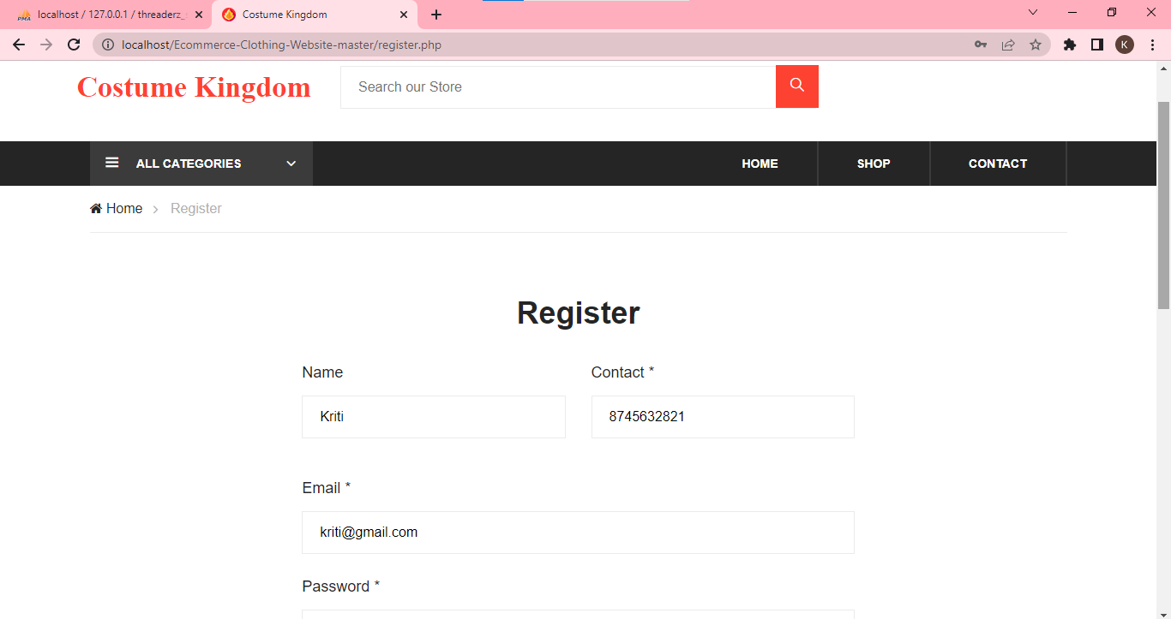 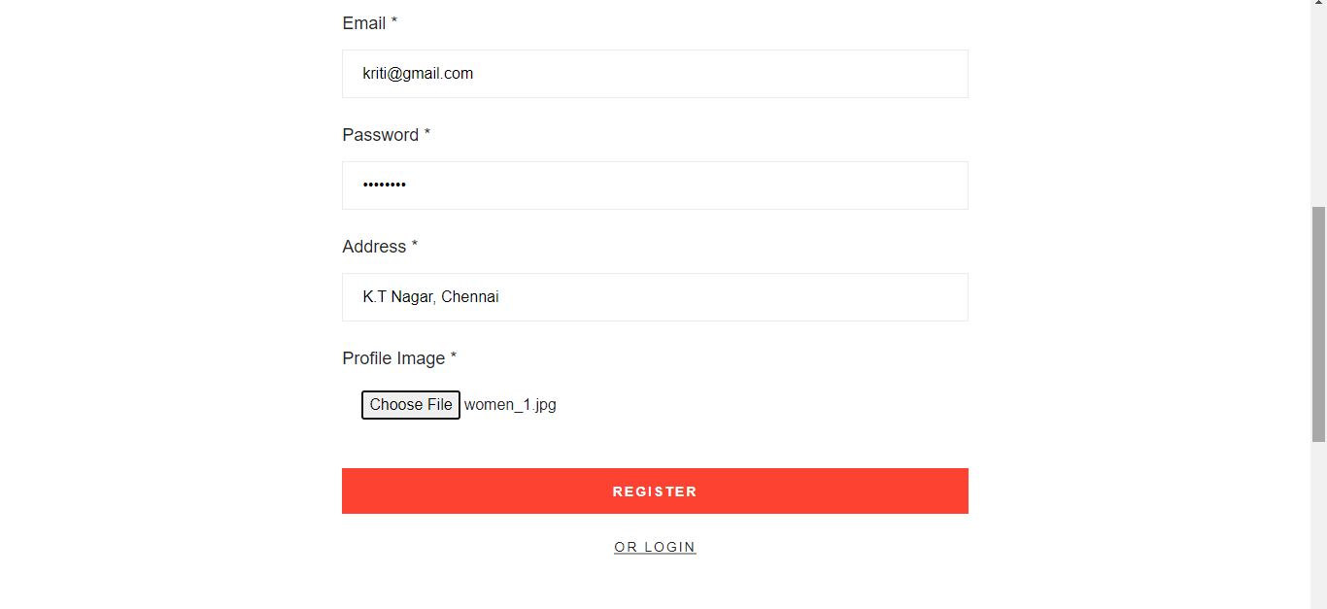

Account registered successfully:

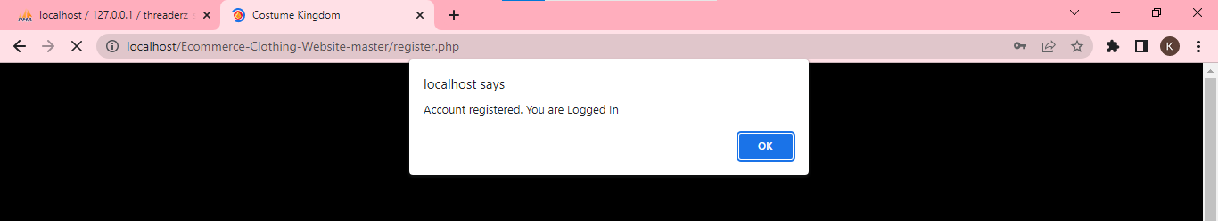

**Login Page:**

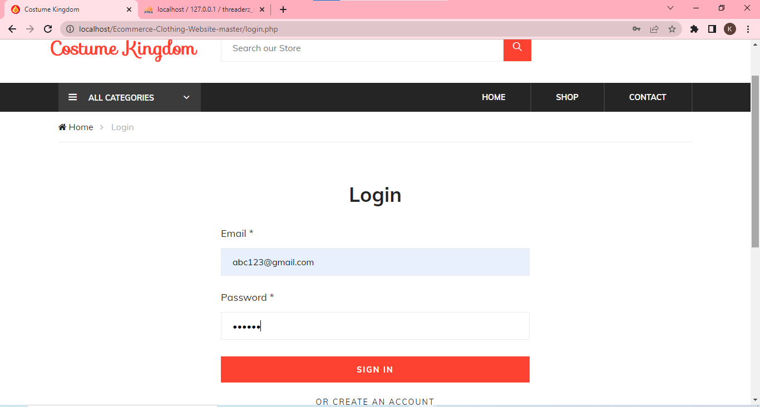

When credentials are invalid:

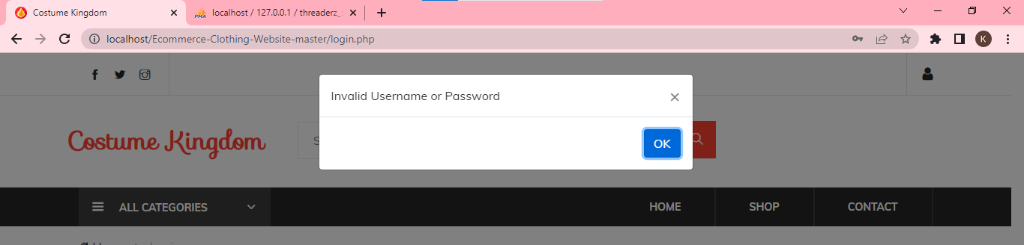

When credentials are valid:

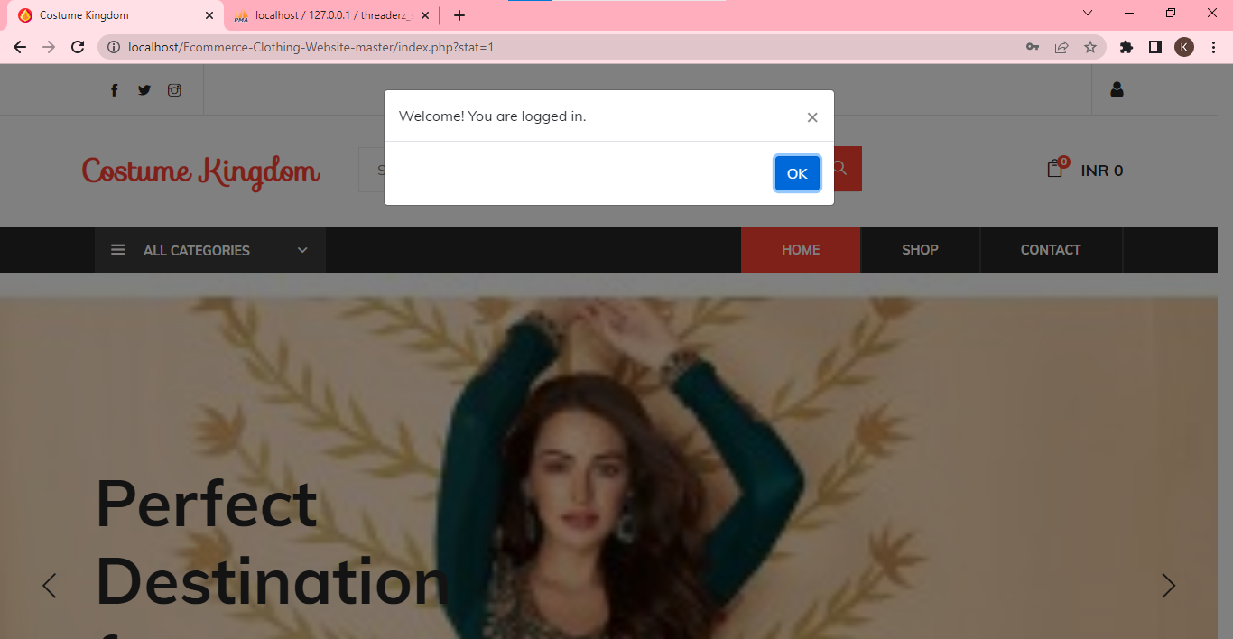

**Home Page:**

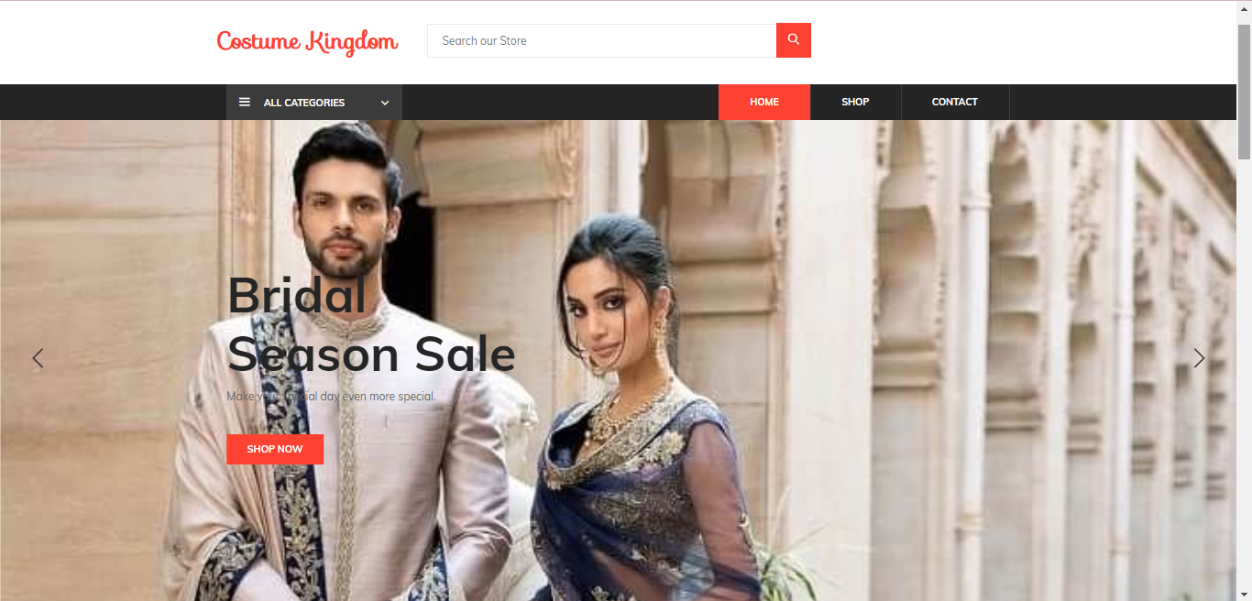 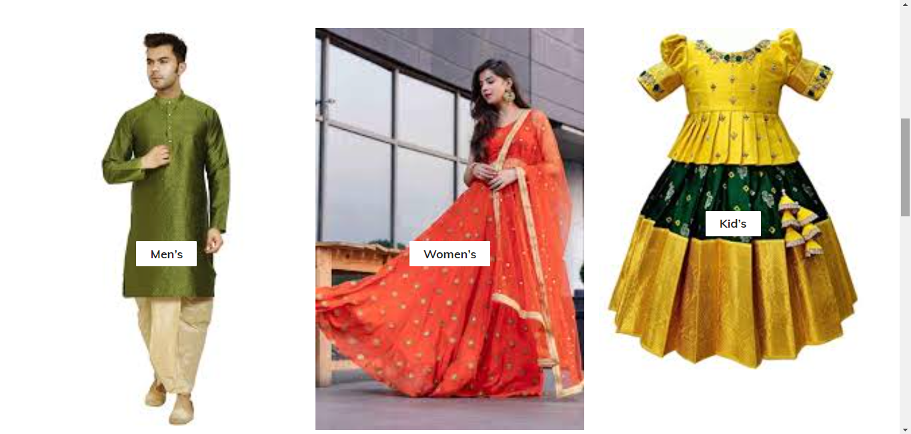 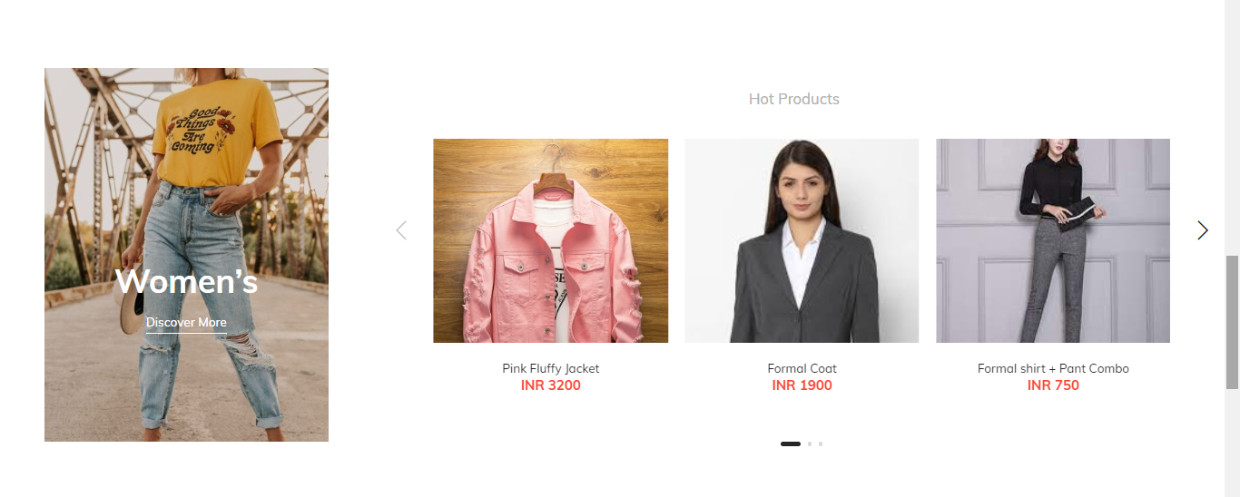 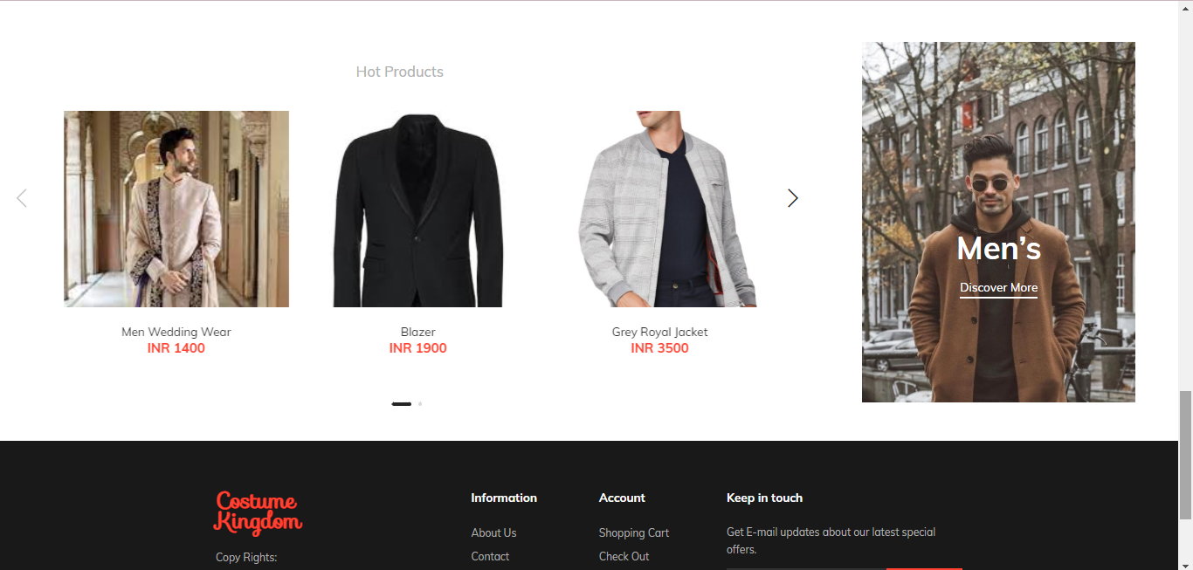

**Shop Page:**

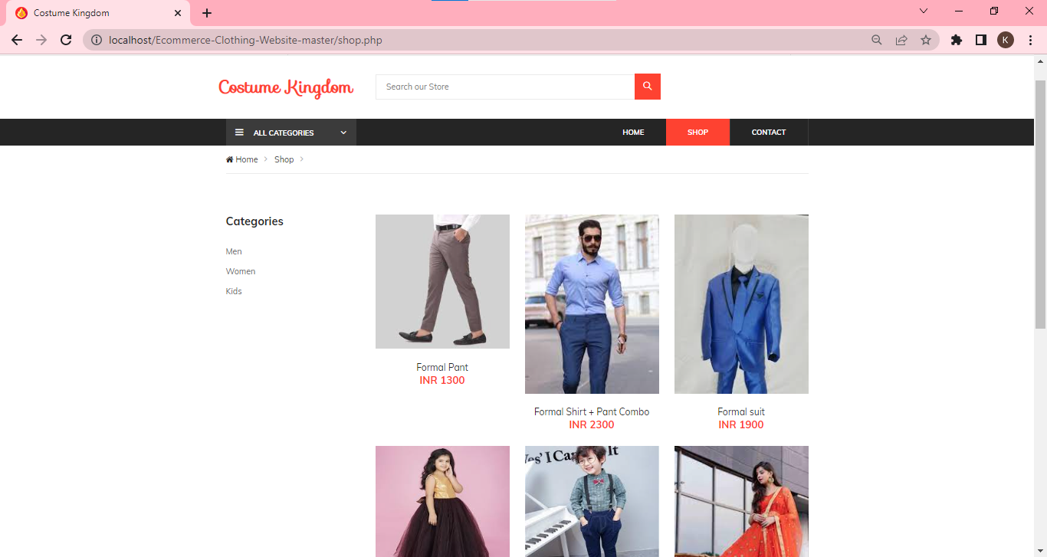

**Men Module:**

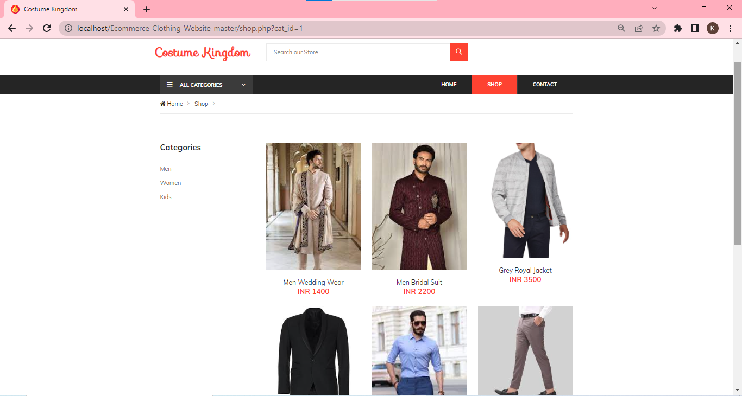

**Women Module:**

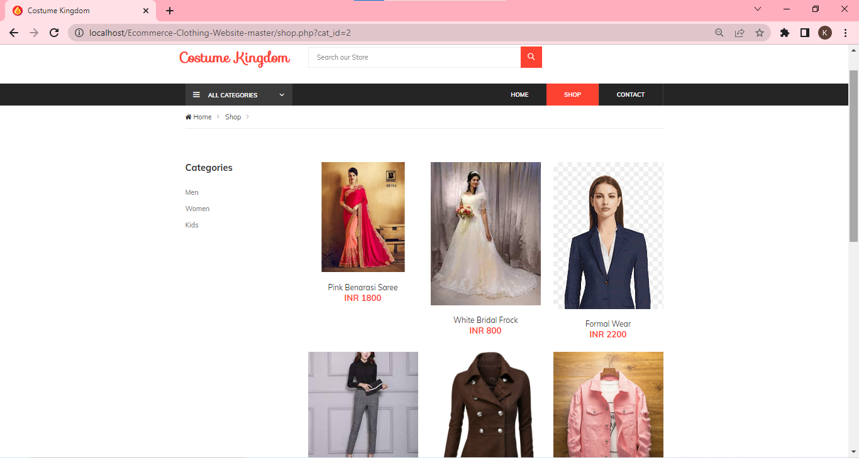

**Kids Module:**

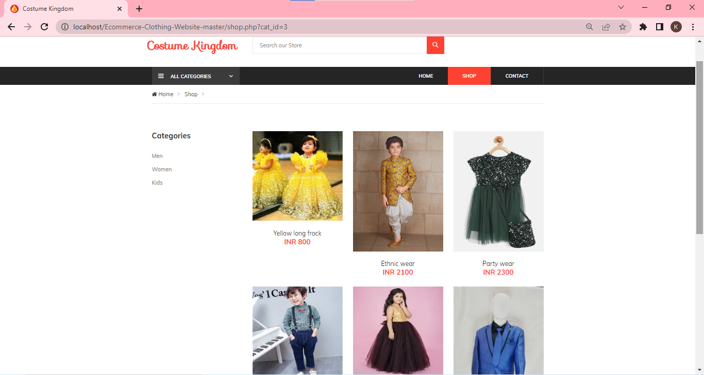

**Product Detail Page:**

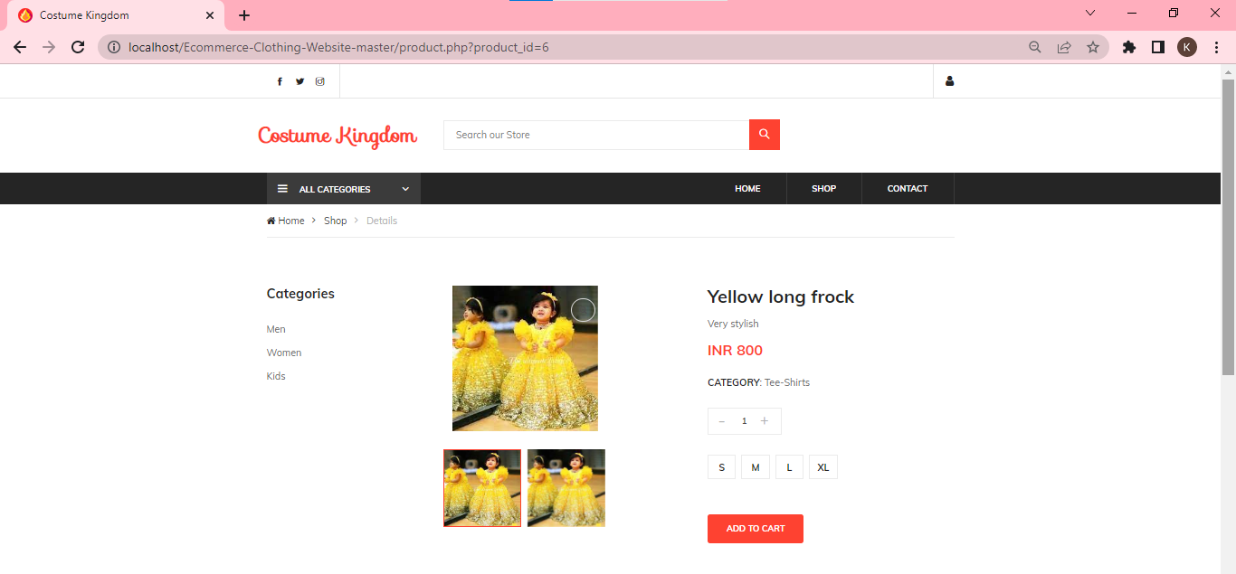

When item added to cart:

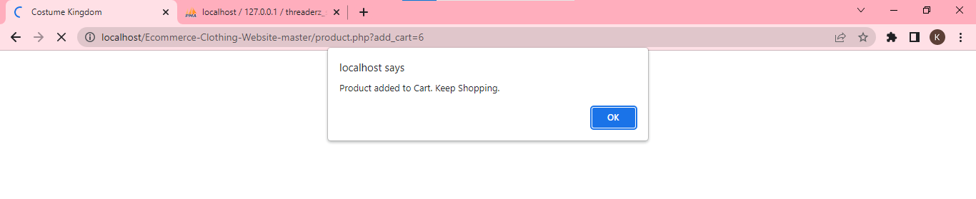

**Shopping Cart Page:**

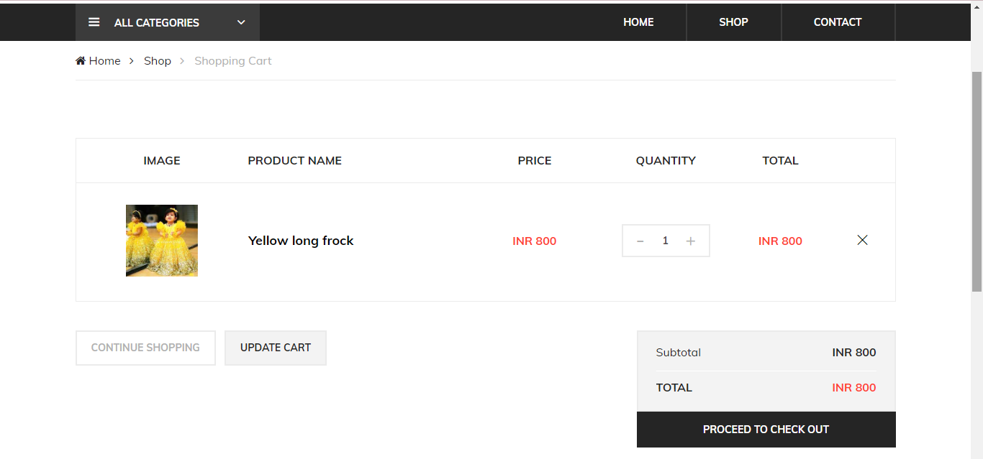

**Check Out Page:**

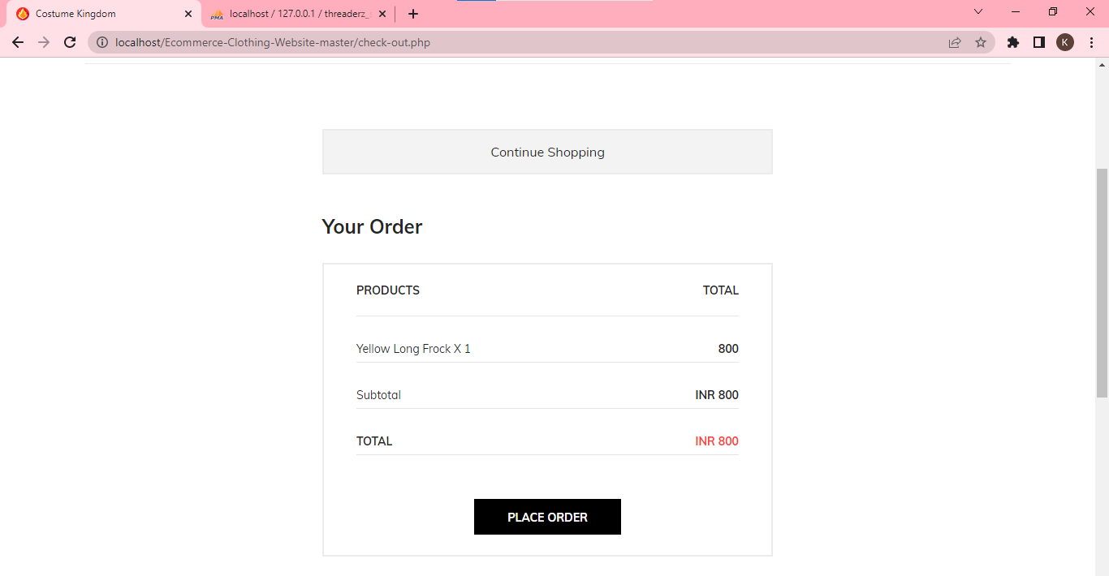

When order is placed:

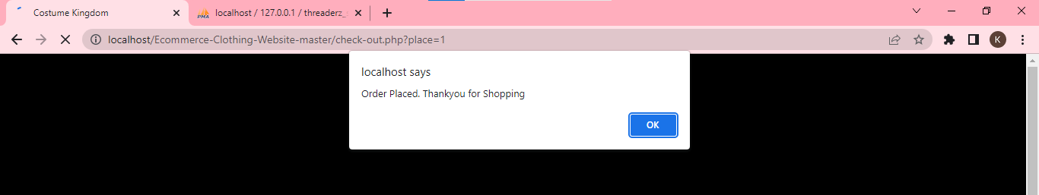

**Orders Page:**

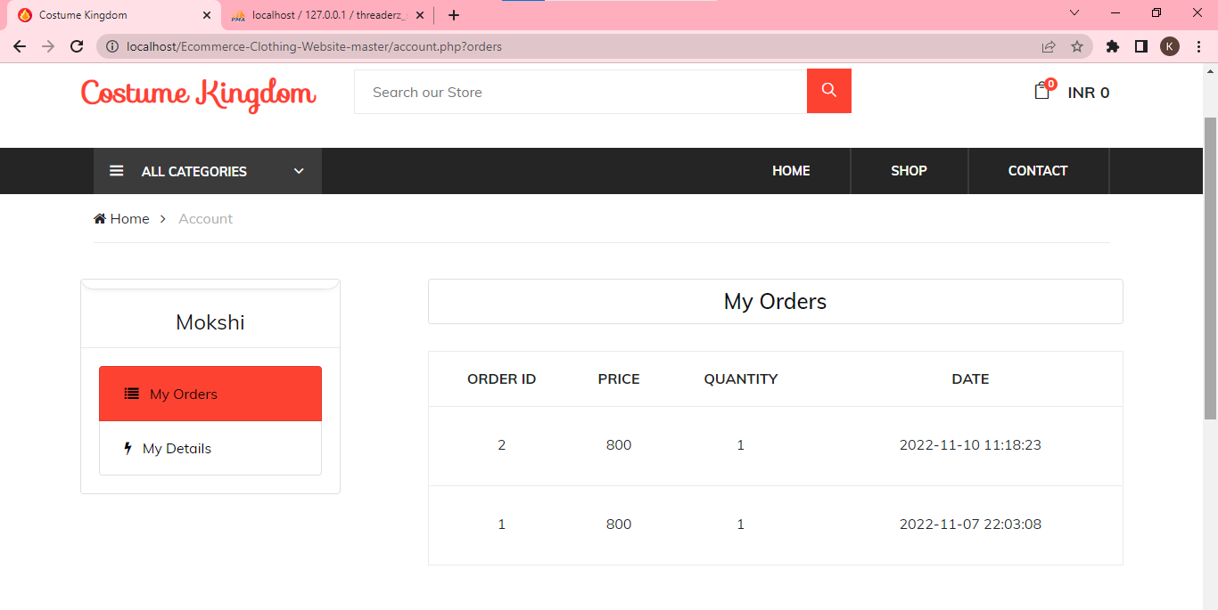

**Account Details Page:**

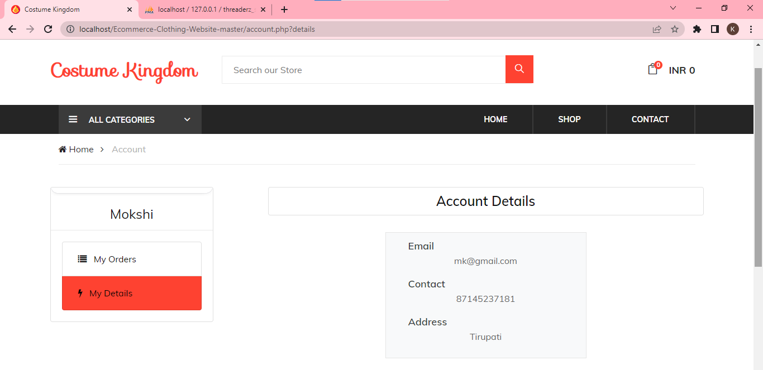

**Contact Us Page:**

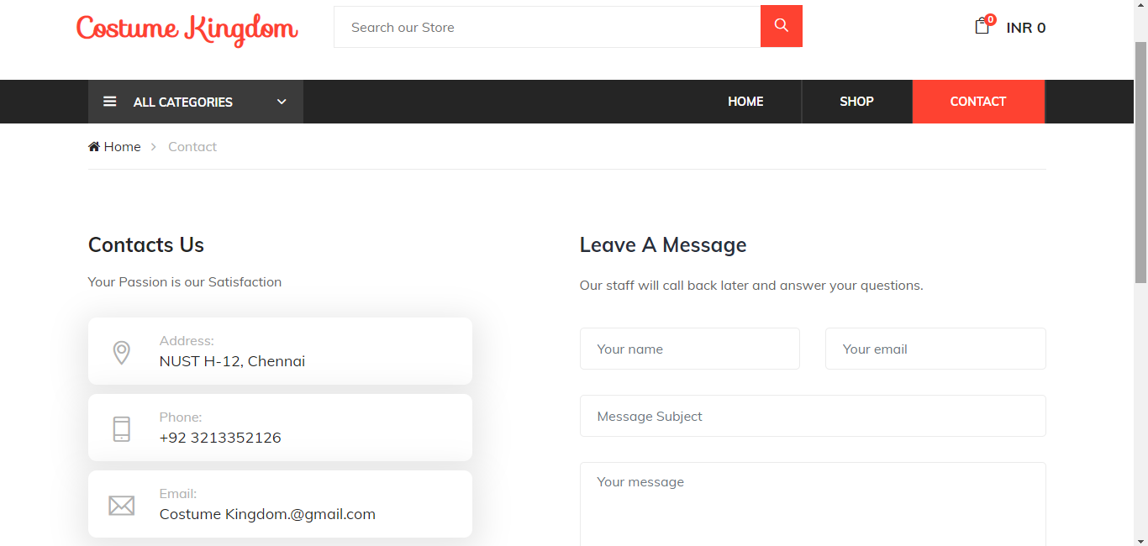

**Backend Database:**

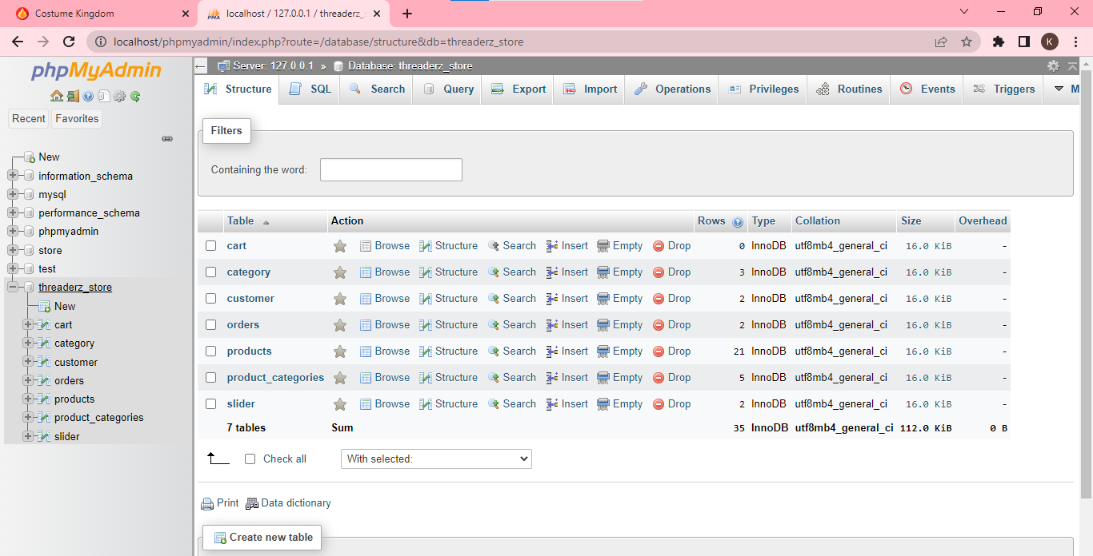

* **Category Table**

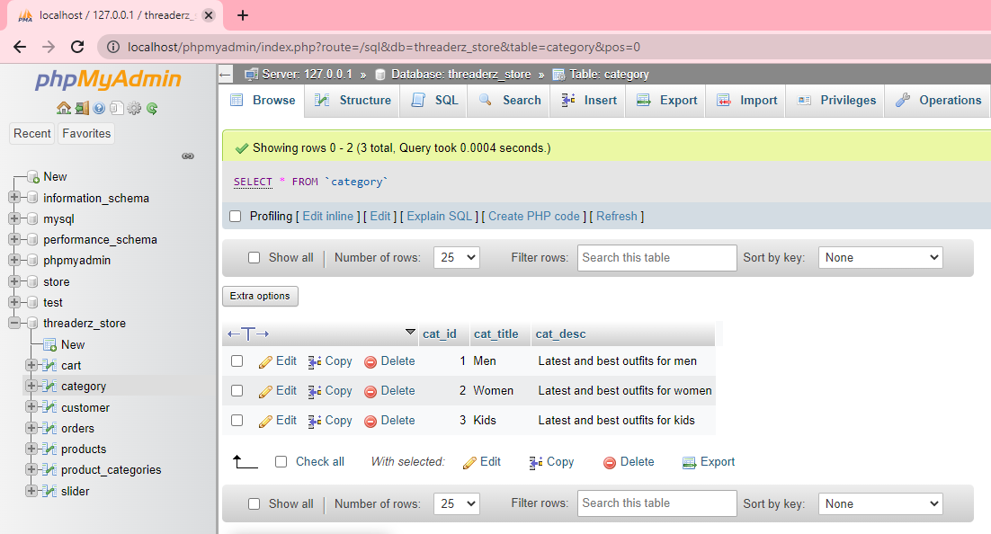

* **Customer Table**

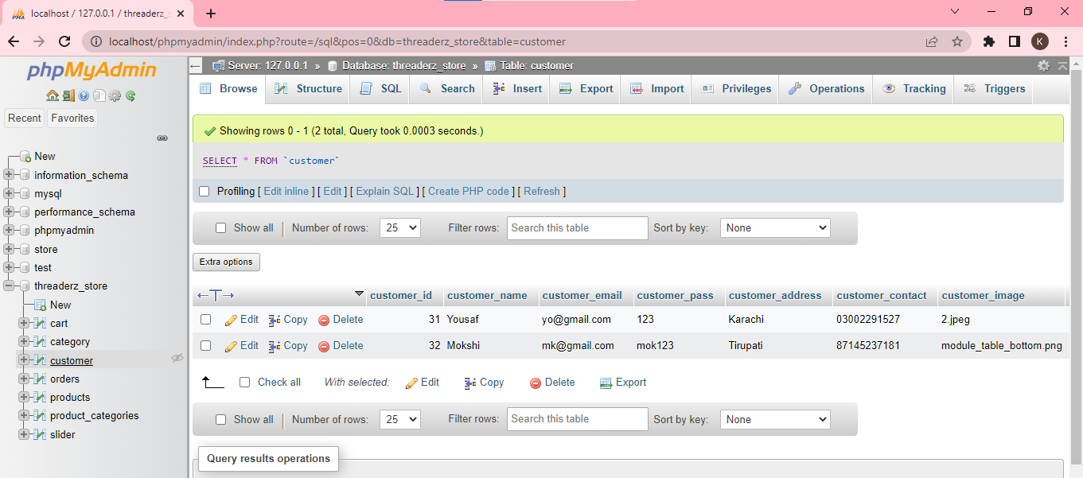

* **Order Table**

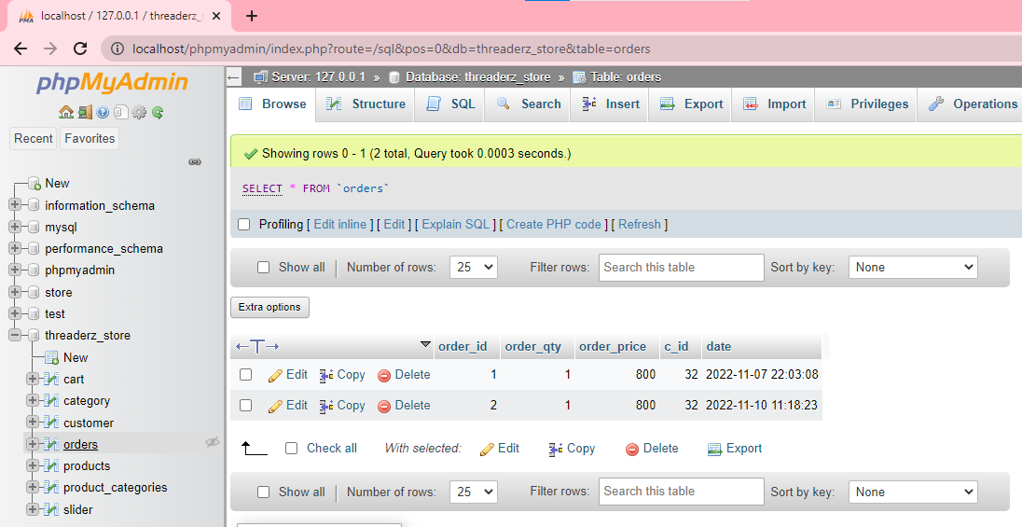

* **Products Table**

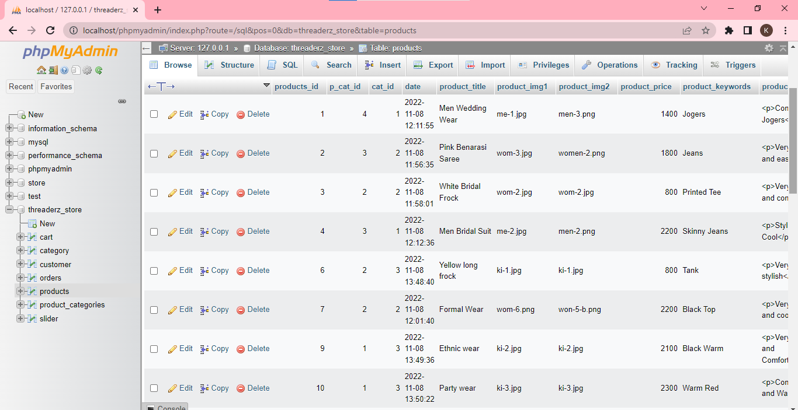

* **Products_Categories Table**

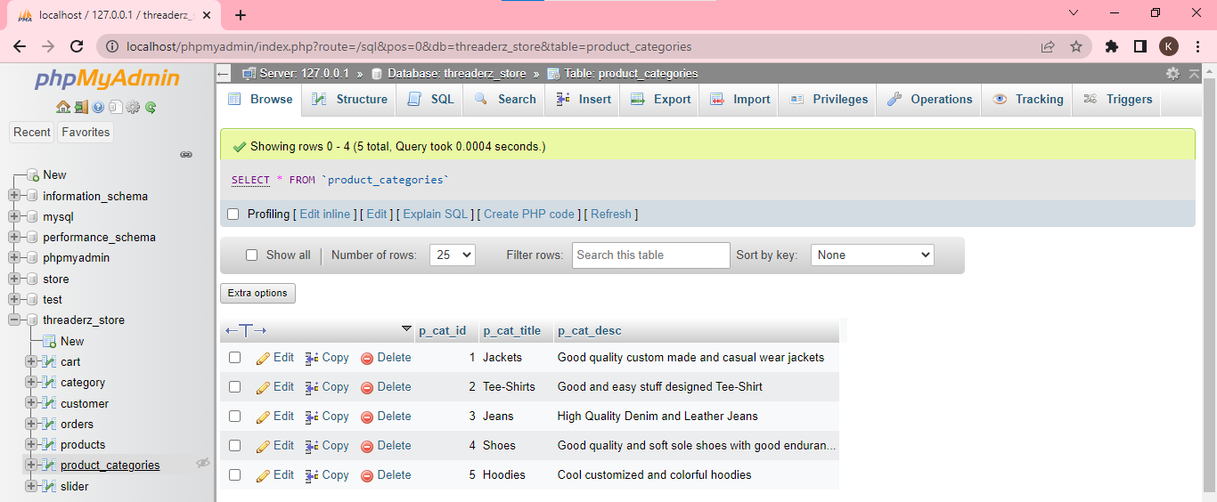

* **Slider Table**

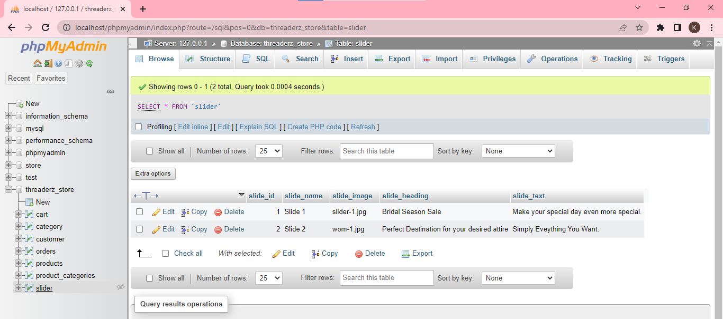

**CONCLUSION**

This website is really helpful for all the people who belongs to economically weaker sections , to those who doesn't show interest to spend money unnecessarily and to those who had purchased some costly outfit for a day and no longer need it.It also reduces the waste of cloth and indirectly helps in to attain eco-friendly environment.

Since the enterprises employ sustainability as their primary business strategy to draw in more clients, renting a product will thus be seen as the most environmentally friendly way to use apparel today. We decided to build a website called "Costume Kingdom.com" for our idea because the rental costume industry is currently growing.

So, we strongly believe that a website like this is more useful to the people of current generation and we are also trying to add new features which enhances our project and marketing this project successfully such that it reaches a wide range of people is the our current motto .

**FUTURE WORK**

In near future, we are planning to rent jewellery that suits the costume. So that clients can select the jewellery and other accomidities that make their outfit look the best amongst everyone from our website. We are planning to add new feature i.e.

quality check where the quality team will go the clients place and check the quality and based on the quality they set a price for the outfit and if the client is willing to sell the outfit for that price then can place their product on our website. We are working to increase automation in the system to meet the user expectations.

**REFERENCES**

Schaefers, T.; Lawson, S.J.; Kukar-Kinney, M. How the burdens of ownership promote consumer usage ofaccess-based services. Mark. Lett. 2016,27, 569–577.

Mohlmann, M. Collaborative consumption: Determinants of satisfaction and the likelihood of using a sharingeconomy option again. J. Consum. Behav. 2015,14, 193–207.

Fisherman, E.; Washington, S.; Haworth, N. Bike share: A synthesis in literature. Transp. Rev.2013,33,148–165.

Sordi, J.D.; Perin, M.G.; Petrini, M.C.; Sampaio, C.H. Construal level and collaborative consumption:An exploratory approach. Int. J. Consum. 2018,42, 264–273.

Iran, S.; Schrader, U. Collaborative fashion consumption and its environmental eﬀects. J. Fash.2017,21,468–482

Johnson, K.K.P.; Mun, J.M.; Chae, Y. Antecedents to internet use to collaboratively consume apparel. J. Fash.2016,20, 370–382.

Devinney, T.M.; Auger, P.; Eckhardt, G.M. The Myth of the Ethical Consumer; Cambridge University Press:New York, NY, USA, 2010.

Lee, S.H.N.; Chow, P.-S. Investigating consumer attitudes and intentions toward online fashion rentingretailing. J. Retail. Consum. Serv. 2020,52, 101892

Tussyadiah, I.P.; Pesonen, J. Drivers and barriers of peer-to-peer accommodation stay: An exploratory studywith American and Finnish travelers. Curr. Issues Tour. 2018,21, 703–720

Rogers, E.M. Diﬀusion of Innovations; Free Press: New York, NY, USA.

K.K.F.; Oh, H.; Min, S. Motivations and constrains of Airbnb consumers: Findings from a mixed-methodsapproach. Tour. Manag. 2018,67, 224–236.